**Computer Fundamental**

**Introduction to Computer**

Computer is an electronic device, which follows instruction and it is capable to perform arithmetic and logical operations, which helps us to perform any given task or work.

Computer is a machine capable of solving problems and manipulating data. It accepts data, processes the data by doing some mathematical and logical operations and gives us the desired output.

Computer is combination of Hardware & Software.

i.e. Monitor, Keyboard, Mouse, CPU are the hardware &Ms office, Windows XP, Tally are Software.

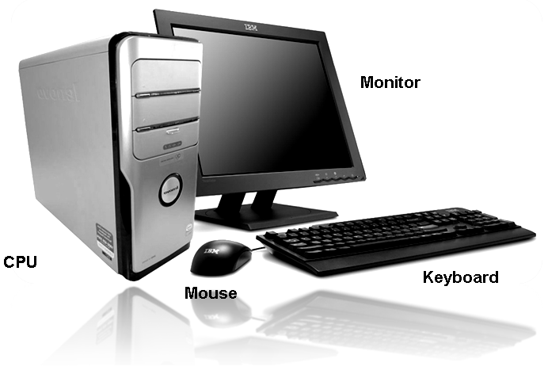

The word “Computer” comes from the word “**compute”** which means to calculate. So a computer is normally considered to be a calculating device that can perform arithmetic operations at an enormous speed. But more accurately, a computer may be defined as a device that operates upon data.

***Data:***

Raw facts are known as Data.

Like programs, videos, songs, documents or input anything’s by you.

***Instruction:***

Command that tells computer to do work / tasks are called instructions.

**Characteristics of Computer**

***Speed:***

Computer is very high speed electronic device.

Computer’s CPU Speed measured in Hz (Hertz) unit.

i.e. Mega Hertz (MHz) & Giga Hertz (GHz)

***Storage Capacity:***

Computer has various storage devices like Hard Disk, Floppy Disk, CD (Compact Disk), DVD (Digital Versatile Disk), Pen Drive, Hard Pocket Drive.

Using these devices user can store large amount of data as well as programs.

These devices capacity measured in byte unit

***Accuracy:***

Computer is 100% accurate machine.

The degree of accuracy of computer is very high and every calculation is performed with the same accuracy

***Consistency (Diligence):***

Computer can do one work 1000% of time.

Computers are the machines that are highly consistent. It never gets bored too! A computer never complains of a monotonous job! Hence, it is ideal machines for carrying out repetitive and voluminous work, twenty four hours a day and 365 days a year.

***Versatility (Flexibility):***

All other machines like television, music player, calculator, or typewriter, do only one thing for which they are designed.

Computer can be used to play music, see movies, type letters, send faxes, fix problems in complex manufacturing operation, design building ad bridges, etc.

**Disadvantages of Computer**

Computer depends on electricity.

It depends on human Instruction.

It has less of common sense.

Computer cannot rectifier the error done by user.

**Application of Computer**

Educational field

Accounting- bank, insurance, stock market, share market

Research and development center

Space Technology

Communication- Railways, Airways, marines.

Printing & Advertisement

**Generations of Computer**

***Babbage’s Analytical Engine***

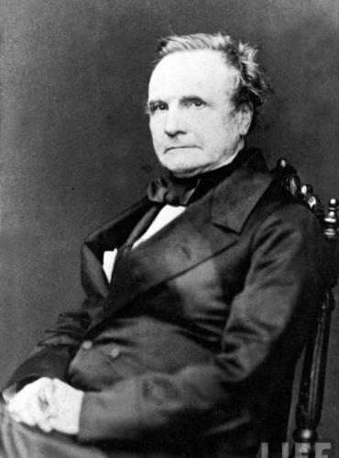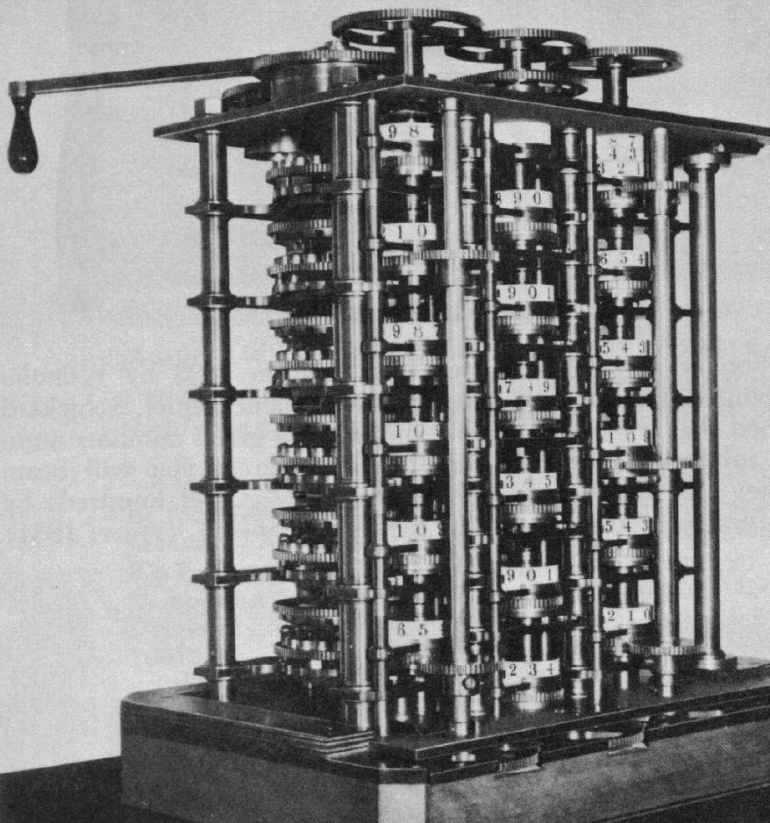

It was in the year 1823 that a famous English man Charles Babbage built a mechanical machine to do complex mathematical calculations. It was called difference engine. Later he developed a general-purpose calculating machine called analytical engine. Charles Babbage is the “father of computer”.

|  |  |  |  |  |  |
| --- | --- | --- | --- | --- | --- |
| **Gen.** | **Period** | **Main Component** | **Speed** | **Size** | **Cost** |
| **1.** | 1946 - 1959 | Vacuum tube | Very Slow | Very Large | In Lack |
| **2.** | 1959 – 1965 | Transistor | Slow | Large | Less Expensive |
| **3.** | 1965 - 1970 | IC  (Integrated Circuits) | Little Fast | Medium | High rate |
| **4** | 1970 to onwards | Microprocessor  (CPU) | Fast | Desktop | Cheap rate |

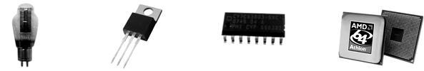

**Vacuum tube Transistor IC Microprocessor**

**History of Computer**

In 1916 the word "computer" refers to a person who makes calculation and computations. Now the word computer portrays a machine that carries out computations. The first computer that I know is the "Abacus", the word abacus came from a Greek word “abax" meaning a calculating table. It is made by the Chinese to calculate billings. It is used for performing arithmetic processes.

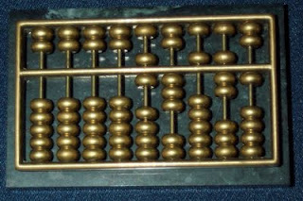

### *The father of computer*

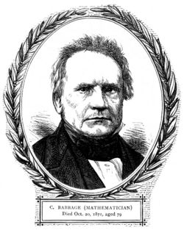

Many people today who uses computer does not really know who made the object (Computer) that is making them entertained, specially teens. An English mathematician named Charles Babbage originated the concept of a programmable computer. He created the first mechanical computer that has led to many more complex designs. He is credited as the father of computers.

**5 Generations of Computers**

**1st generation**

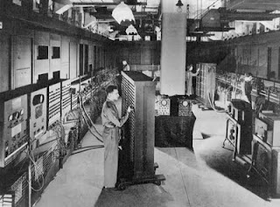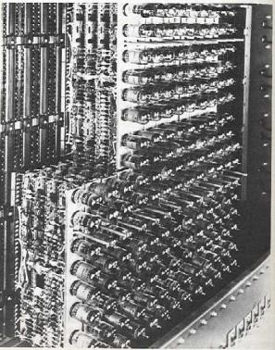

Computers in the 1940’s use vacuum tubes for data storage. This Vacuum tube is too enormous that it can take up an entire room. Computers in this generation uses great amount of electricity that generates a lot of heat that often cause malfunctions. UNIVAC and ENIAC are examples of the first generation computers that use the machine language.

**2nd generation**

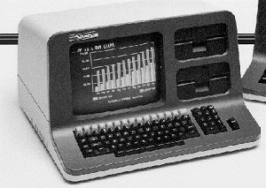

In this generation, the Transistor was invented. The transistor is better than the vacuum tubes because it is smaller and more energy efficient.  It still uses punch cards for inputs and printouts for outputs.

**3rd generation**

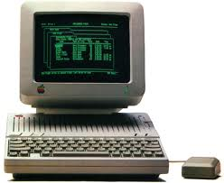

Transistors in these generations were miniaturized and were placed on silicon chips, these results to a great increase of computers. Instead of using punched cards and printouts, a keyboard and a monitor were invented and the computer was interfaced with an OS that allows applications to run at one time. Again computer was made smaller and cheaper

**4th generation**  
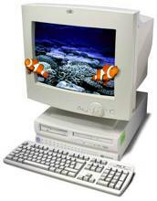

In this generation, microprocessors are created. Wires, memory output and input are put onto a small microchip. Central Processing Unit (CPU) and mouse and other handheld devices are invented in this generation. This generation of computer is small but more powerful than the other past generations. It can also access the internet and can link to other networks.

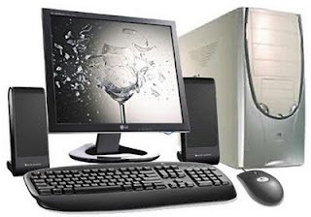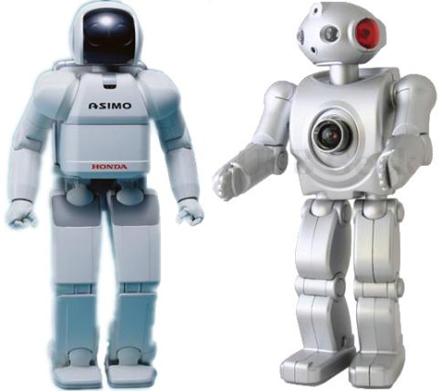

This generation is the present-future of computers that we are using today. Much development is still ongoing; this computing device is based on Artificial Intelligence (AI). Computers nowadays can make quantum computations. It can also self organize also can respond to natural languages.

***First Generation Computers:***

First generation computers used Thermion valves. These computers were large in size and writing programs on them was difficult.

Some of the computers of this generation were:

ENIAC: It was the first electronic computer built in 1946 at University of Pennsylvania, USA by John Eckert and John Mauchy. It was named Electronic Numerical Integrator and Calculator (ENIAC). The ENIAC was 30-50 feet long, weighed 30 tons, contained vacuum tubes, 7000 registers, 10000 capacitors and required 150000 watts of electricity.

***Second Generation Computers:***

Around 1959 a device called Transistor replaced the bulky electric tubes in the first generation computer. Transistors are smaller than electric tubes and have higher operating speed. Thus the size of the computer got reduced considerably.

***Third Generation Computers:***

The third generation computers were introduced in 1965. They used Integrated Circuits (ICs). These ICs are popularly known as Chips. A single IC has many transistors, registers and capacitors built on a single thin slice of silicon. So it is quite obvious that the size of the computer got further reduced. Some of the computers developed during this period.

***Fourth Generation Computers:***

The present day computers that you see today are the fourth generation computers that started around 1970. It uses large scale Integrated Circuits (LSIC) built on a single silicon chip called microprocessors. Due to the development of microprocessor it is possible to place computer’s central processing unit (CPU) on single chip. These computers are called microcomputers. The personal computer (PC) that you see in your school is a Fourth Generation Computer.

***Fifth Generation (Under Development):***

The speed is extremely high in fifth generation computer. These machines are parallel processing techniques and artificial intelligence similar to the one used by the human brain. Therefore, these computers are being designed to think as human beings do. They will store very large amount of information, make expert judgment and take accurate and timely decision. This machine, when fully developed, will be able to process non numerical data such as pictures, graph, etc. they will use new type of integrated circuits for fasters speed of operation. They will also use fiber optics, bubble memory and voice recognition techniques. Such machines are under development in USA and JAPAN. The country which comes out first with these machines will be the winner in the race of computers.

## Artificial Intelligence

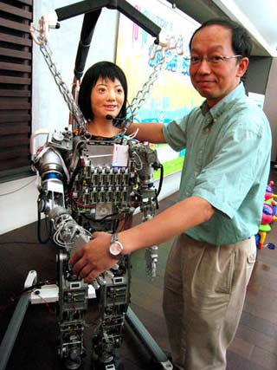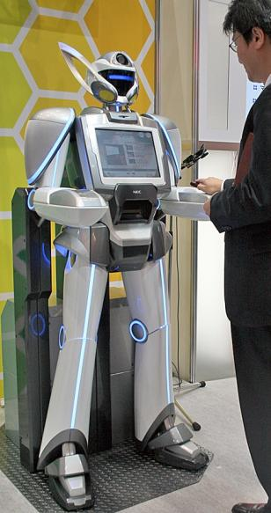

You hear about it in many movies, magazines, television, and even through word-of-mouth. Movies like *The Terminator* and *Eagle Eye* are just a few films that depict the dangers of artificial intelligence. Artificial intelligence is the intelligence of machines and the branch of computer science which aims to create it. It is a serious issue which we are letting slip through our fingers due to our need to make life easier.

When the hit artificial intelligence box-office movies came out, people started realizing the dangers that artificial intelligence can have on human life. Immediately and still today, we have a negative outlook on the idea of robots and human machines. Unfortunately, this does not end here. Many large corporations are working on building robots to be used for human service. Little by little, we are accepting this with the advancement of technology and computers.

What if one day someone shut off all the electricity in the world? Will we survive or will the human race go into chaos? We rely on computers every day to help us live a normal life and to make life easier for ourselves. Every day, you read about this new electronic like the iPhone and see how beneficial it can be for us. We put our trust in electronics than we do in others. As technology keeps improving, what if human robots were made available cheaply to be used as human service? Sure, they can replace maids and butlers, but can we put our trust in a machine?

The advancement of technology has made life more comfortable and easier, but it has also put our lives in greater danger. Information has become easier to access and also easier to steal and manipulate. Ten years ago, iPhones, iPods, and even iRobots were barely thought of. We all have to realize when to stop because the stakes are getting higher. Like I have said before, we are slowly, little by little, accepting the idea of artificial intelligence and completely ignoring the risks.

We all have to use our own judgment on whether or not we will put a limit on the development of artificial intelligence. Otherwise, we are putting the entire human race in great danger.

**Types of Computer**

Computer divided into different categories depending upon the size, efficiency, memory and number of users. Broadly they can be divided it to the following categories.

***Microcomputer:***

Microcomputer is at the lowest end of the computer range in terms of speed and storage capacity. Its CPU is a microprocessor. The most common application of personal computers (PC) is in this category. The PC supports a number of input and output devices.

Examples of microcomputer are Desktop & Laptop.

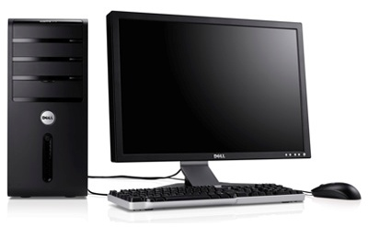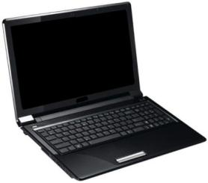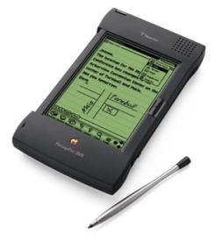

***Mini Computer:***

This is designed to support more than one user at a time. It possesses large storage capacity and operates at a higher speed. The mini computer is used in multi-user system in which various users can work at the same time. This type of computer is generally used for processing large volume of data in an organization. They are also used as servers in Local Area Networks (LAN).

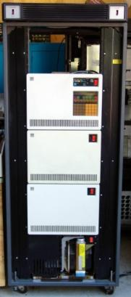

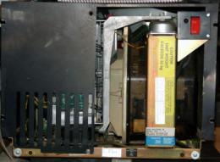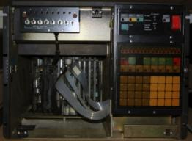

***Mainframes:***

These types of computers are generally 32-bit microprocessors. They operate at very high speed, have very large storage capacity and can handle the work load of many users. They are generally used in centralized databases. They are also used as controlling nodes in Wide Area Networks (WAN). Example of mainframes are DEC, ICL and IBM 3000 series.

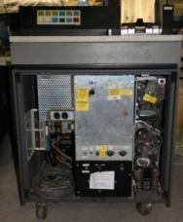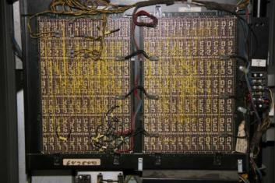

***Supercomputer:***

They are the fastest and most expensive machines. They have high processing speed compared to other computers. They have also multiprocessing technique. One of the ways in which supercomputers are built is by interconnecting hundreds of microprocessors. Supercomputers are mainly being used for weather forecasting, biomedical research, remote sensing, aircraft design and other areas of science and technology. Examples of supercomputers are CRAY YMP, CRAY2, NEC SX-3, CRAY XMP and PARAM from India.

# IBM Blue Gene P Supercomputer

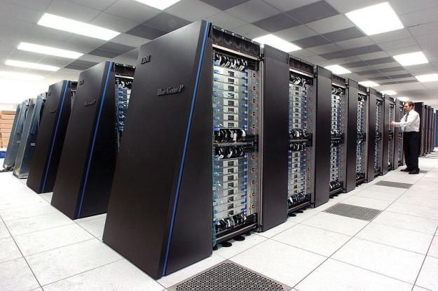

**Computer Language**

Computer understands only binary Language.

Binary means bits i.e. 0’s and 1’s.

***Understanding Binary Code***

This is all very simple really. We'll take it one step at a time. First, binary code is also known as Base Two (bi means two, as in **Bi**cycle or **Bi**lingual). Computers use Base Two because all of the work is done by transistors; tiny switches with no moving parts. The switches can either be OFF (0) or ON (1). Check out the power switch on your appliances at home. Many of them will show 0 and 1 (off and on). Learning Base Two is easy and fun. In order to proceed, you must first understand how number systems work.

In Base Two, things work like this:

1. There are two numerals.   01

2. Each place value is two times bigger than the one to its right.  Eights Fours TwosOnes

If you are 13 years old (Base Ten), you would be 1101 in Base two; 1 eight, 1 four, 0 twos, and 1 one. Add them. If you think this is weird, be glad that you are not 101110 like me! Here's what the place values look like to a computer. Each place value represents a switch (on or off). Each one is called a bit, and the computer reads them in packs of 8 (byte).

|  |  |  |  |  |  |  |  |
| --- | --- | --- | --- | --- | --- | --- | --- |
| 128 | 64 | 32 | 16 | 8 | 4 | 2 | 1 |

Did you notice that the place values go up like the newest version of Nintendo or Sega? This is not an accident; they read binary also! A byte that contains the number 13 would look like this: 00001101

|  |  |  |  |  |  |  |  |
| --- | --- | --- | --- | --- | --- | --- | --- |
| **0** | **0** | **0** | **0** | **1** | **1** | **0** | **1** |
| 128 | 64 | 32 | 16 | 8 | 4 | 2 | 1 |

To convert a Base Ten number to Base Two, first make a place value guide to keep you from getting lost.

|  |  |  |  |  |  |  |  |
| --- | --- | --- | --- | --- | --- | --- | --- |
|  |  |  |  |  |  |  |  |
| 128 | 64 | 32 | 16 | 8 | 4 | 2 | 1 |

Let's convert the number 46. First, determine what would be the biggest switch (place value) that you could turn on without going over? That's correct: 32. Now, put a 1 in the 32s place to turn on that switch.

|  |  |  |  |  |  |  |  |
| --- | --- | --- | --- | --- | --- | --- | --- |
|  |  | **1** |  |  |  |  |  |
| 128 | 64 | 32 | 16 | 8 | 4 | 2 | 1 |

Now, 32 has been used up, so how much is left? 46-32=14 so, what is the next biggest switch (without going over, remember) that we can turn on? That's right, the 8 switch!

|  |  |  |  |  |  |  |  |
| --- | --- | --- | --- | --- | --- | --- | --- |
|  |  | **1** |  | **1** |  |  |  |
| 128 | 64 | 32 | 16 | 8 | 4 | 2 | 1 |

How much is left? 14-8=6 The next biggest switch we can turn on is the 4s switch.

|  |  |  |  |  |  |  |  |
| --- | --- | --- | --- | --- | --- | --- | --- |
|  |  | **1** |  | **1** | **1** |  |  |
| 128 | 64 | 32 | 16 | 8 | 4 | 2 | 1 |

How much is left? 6-4=2  We turn on the 2s switch.

|  |  |  |  |  |  |  |  |
| --- | --- | --- | --- | --- | --- | --- | --- |
|  |  | **1** |  | **1** | **1** | **1** |  |
| 128 | 64 | 32 | 16 | 8 | 4 | 2 | 1 |

What's left? 2-2=0 There is nothing left, so fill the remaining places with 0 (off).

|  |  |  |  |  |  |  |  |
| --- | --- | --- | --- | --- | --- | --- | --- |
| **0** | **0** | **1** | **0** | **1** | **1** | **1** | **0** |
| 128 | 64 | 32 | 16 | 8 | 4 | 2 | 1 |

So, the number 46 looks like this as a byte:  00101110

Not sure is it is correct? Add up the places that are turned ON. 32+8+4+2=46

***Bits & Bytes:-***

* 1. Bit or Binary Digit i.e. number 0 and number 1 are the most basic information that one can store inside the computer.
  2. A single bit can be stored inside the computer using capacitors, using bistablemultivibrator such as flip-flops, using the transistor as a switch, or by using a relay etc.
  3. As a single bit alone does not provide much information, a combination of these bits are used to convey different information.
  4. When two bits are used they can be combined in four different ways 00, 01, 10 and 11 and each combination can convey different information.

***Computer signal:-***

There are two types of signals

1. ***Analog Signal*** It is a signal like heart bits

1 - ON Signal (High Signal)

0 - OFF Signal (Low Signal)

0

1

0

1

1

1

1

1

1

1

0

0

0

0

0

0

1. ***Digital Signal***

***Storage Capacity:-***

A combination of 4 bit, called a “nibble” and is used to store information inside the calculators, as the 4 bit can have 24 = 16 different combination, it is enough to convey 10 different digits (0 to 9) and some additional information such as decimal point etc.

The computer can manipulate characters as well as numbers, so a combination of 8 bits (called a “byte”) is used inside the computer to store different characters.

A combination of 8 bits can have 28 = 256 different combinations, which is enough to convey all the alphabet, lower case, upper case, numbers, and various special text and graphic symbols used by the computer.

Inside the computer one byte or 8 bits can store one character, a character can be any alphabet, number or special symbols such as @, #, $, * etc.

* 1 bit = a 1 or 0
* 4 Bits is called a 1 Nibble.
* 8 Bits is called a 1 Byte.
* 1024 Byte is called a Kilo Byte (1 KB)
* 1024 KB is called a Mega Byte (1 MB)
* 1024 MB is called a Giga Byte (1 GB)
* 1024 GB is called a Tera Byte (1 TB)
* 1024 TB is called a Peta Byte (1 PB)
* 1024 PB is called a Exa Byte (1 EB)
* 1024 EB is called a Zetta Byte (1 ZB)
* 1024 ZB is called a Yotta Byte (1 YB)

**Computer**

**Readymade**

**Application**

**Software**

**Operating**

**System**

**Network Operating**

**System**

**Hardware**

**Software**

**Application Software**

**System Software**

Dos

Windows

Linux

Linux

Windows Server

Novell Netware

UNIX

Motherboard

Hard disk drive

Floppy disk drive

CD-ROM drive

RAM (Memory)

SMPS

Display Card

LAN Card

Microprocessor

CPU Fan

Modem Card

AGP Card

Monitor

Speaker

Keyboard

Mouse

Microphone

Printer

Scanner

Joystick

External Modem

Pen drive

MS Office

CorelDraw

Tally

Photoshop

PageMaker

Nero

MS Paint

C, C++

Java

. Net

VB

Oracle

**External component**

**(Peripheral part)**

**Tailor made**

**Application**

**Software**

Macintosh

**Internal component**

**(CPU part)**

Sun Solaris

Ubuntu

External HDD

**Computer Tree Diagram**

**Computer Fundamental**

**Hardware concept**

**Hardware**

The physical parts (component) of the Computer, that we can see and touch, those parts are Hardware.

Such item may be electric, electrical, magnetic, mechanical or optical components.

Examples of components are microprocessors, ICs, Hard disks, Floppy disks, Optical disks, Monitors, keyboard, Printer, Plotter, etc.

i.e. CPU (Central Processing Unit), Input Devices (Keyboard, Mouse, Scanner, etc.), Output Devices (Monitor, Printer, Speaker, etc.)

A computer system is composed of a CPU (Central Processing Unit), a keyboard, a Visual Display Unit (VDU) i.e. a monitor, peripheral devices and an operating system.

Computer’s Hardware Component is divided into two categories

* **Internal Components (CPU Parts)**
* **External Components (Peripheral Parts)**

Internal component is inside the CPU cabinet like,

Motherboard , Microprocessor, Hard Disk Drive, Floppy Drive, CD/DVD Drive, RAM, SMPS, Display Card, LAN Card, CPU Fan, Modem Card, AGP Card, etc. and

External Component is connected to CPU Cabinet like,

Monitor, Keyboard, Mouse, Speaker, Printer, Scanner, Pen drive, Joystick, Router, TV Tuner, Web Camera, etc.

**Internal Component of the Computer**

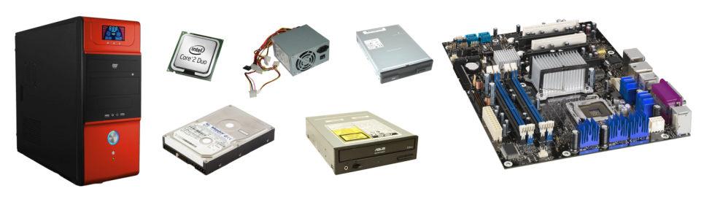

**External Component of the Computer**

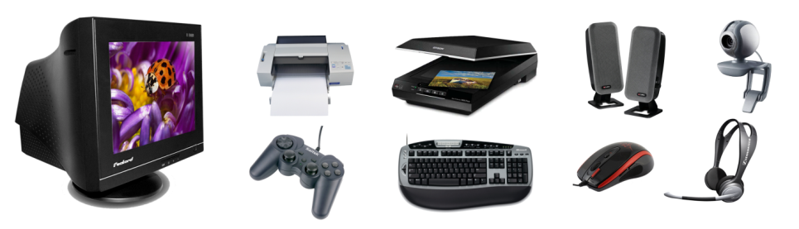

***Process of Computer (Data Processing)***

***Process of Computer (Data Processing)***

***CPU (Central Processing Unit):***

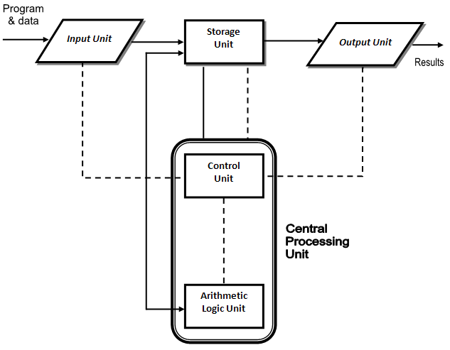The CPU is the brain of a computer. Its primary job is to run program and control the operation of all other components such as memory, keyboard and printer.

A block diagram of the basic computer organization is shown in figure.

In this figure, the solid lines are used to indicate the flow of instructions and data. The dotted lines represent the control exercised by the control unit. The figure shows the basic arrangement of different units of a computer. It depicts the five major building blocks, or functional units of a digital computer system. These five units correspond to the five basic operations, namely inputting, storing, processing, outputting and controlling data, carried out by all computer systems. The five units are explained in the following paragraphs:

***Inputting:*** Refers to the process of entering data into the computer, by the user using an input device, such as keyboard.

***Storing:*** Refers to the holding of data and instruction in the computer’s main memory, for manipulations.

***Processing:*** Refers to performing operations (both arithmetic and logical) or manipulation of data entered into the computer so that useful information may be taken out of the entered data.

***Outputting:*** Refers to the process of showing the information or result to the user either on screen (monitor) or on paper (through printer).

***Controlling:*** Refers to directing all the above processes, in coordination. This controlling is done by the Control Unit (CU) in a Central Processing Unit (CPU).

**Software concept**

**Software**

Software is a set of instruction that tell the Hardware How to perform a task; without software, the hardware part will not work.

It is the set of computer programs, procedures, and associated documentation related to the effective operation of a computer system.

A set of instruction that perform a particular task is called the program, or software program. The instructions in the program direct the computer to perform input operations, process the data and output the result.

Depends on functioning software is divided into two categories.

MS-DOS

Windows

Linux

Mac

Ubuntu

Boss

Amiga

Windows Server

Unix

Notepad

Paint

MS-Office

CorelDraw

Photoshop

Tally

Internet Explorer

C Prog.

C++

Java

Visual Basic

Oracle

SQL Server

.Net

**System Software**

System software is set of one or more programs that are basically designed to control the operation of a computer system. They are general programs written to assist users in the use of the computer system by performing tasks, such as controlling all of the operations, moving data into and out of a computer and all of the other steps in executing the application program.

System software supports the following point.

* Running of other software
* Communicating with peripheral devices such as Printers, Card readers, Pen drive Scanner, Mic, etc.
* Development of other types of software
* Writing the information or data in other devices like memory, hard disk

Types System Software

* Operating System
* Network Operating System

**Operating System**

An operating system is system software, which is used to make relationship between hardware & software, OS controls the internal activities of the computer hardware and provides user interface.

An operating system is a master control program that runs the computer ad acts as a scheduler. It controls the flow of signals from CPU to various parts of the computer.

It is the first program loaded (copies) into the computer’s memory after the computer is switched on.

An operating system (OS) is a set of system software programs in a computer that regulate the ways application software programs use the computer hardware and the ways that users control the computer. For hardware functions such as/input/output and memory space allocation, operating system programs act as an intermediary between application programs and the computer hardware. Although application program are usually executed directly by the hardware. Operating systems is also a field of study within applied computer science.

The job of operating systems for a computer is mainly to manage the hardware and software resources of the system. In desktops & laptops the hardware resources include processes, hard disk, memory, disk space, mouse, printers, other peripherals, etc. whereas the software resources are the various software application being used on that desktop/laptop. Operating system also plays a very important role in providing a consistent interface for the applications irrespective of the hardware or peripherals used. There may be different drivers used along with the operating system for these purpose.

Type of Operating System

* DOS
* Windows
* Linux
* Unix
* Mac
* Ubuntu
* BOSS
* Amiga

**Windows**

Windows is an Operating system; an operating system is as system software that allows the user to interact with computer.

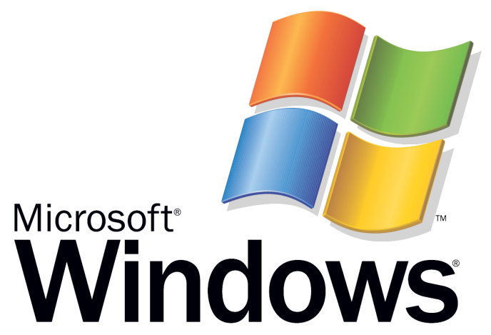

**History of windows**

The 1st success version of windows was 3.0, 3.11, then Windows 95, Windows 98 before Windows the Microsoft Operating System was DOS (Disk Operating System).

Win-NT, Win-Me, Win-XP, Win-2000, Win-2003 server, Win-Vista, Win-7, Win-2007 server are Microsoft Windows operating system.

***Feature of Windows***

1. **GUI (Graphical User Interface): -** Windows supports Graphical User Interface. It makes friendly environment between user and Computer.
2. **Multi user: -** Windows supports multi using that means one File or Folder can be open (accessed) more than one computer at a given point of time.
3. **Multi Tasking: -** Windows supports multi tasking that means you can work more than one application at a given point of time on one computer.
4. **Long File Name: -** Windows supports long file name that means you can save a file of name up to 256 Character.

File name consist two parts

(* . *) (Where left side (*) is file name & right side (*) is file extension)

* Primary (File name) [ you type any name]
* Secondary ( Extension) [ *.txt, *.doc, *.xls, *.ppt)

1. **Plug and play: -** it supported plug and play feature that means you can attached or detached any Hardware devices from windows of any point of time.

***Basics of Windows Operating System***

One of today’s most common operating system is “Microsoft Windows”. It is the world’s largest selling operating system for PC’s.

Windows belongs to the categories of software called a GUI (Graphical User Interface). The user interface determines how you interact with your computer. The hardware part of the interface consists of your screen monitor, the keyboard and the mouse. The software part of the interface determines what things look like on the screen and how you give command to your PC to get your work done. Before windows this was done with keyboard commands, and therefore using operating system was quite cumbersome. With the advent of windows environment, many of everyday computer tasks such as running programs, opening files, choosing commands, etc. are done using a graphical approach that is very easy to new users of computers. Further, windows programs use the same command structure and graphical item on the screen, so if you have mastered one windows program, learning other program becomes very easy.

As soon as you switch on the power supply windows operating system program loaded in PC after initial checks and takes the PC’s control. It provides the communication link between your computer hardware & the software that you use. For example when you tell your spread sheet software to save a file, the operating system tells the computer system how and where to save it.

However, windows are more than an operating system. It provides functions that let you manage many programs simultaneously, customize PC, and do many of the maintenance tasks associated with a PC it also comes with many accessories, software program, such as utilities media player, etc.

Windows takes care of PC and does many things in the background that are not visible to you. It keeps busy behind the scenes managing your software packages and hardware working.

Windows does the following jobs;

* Provides ways for you to start application programs.
* Runs more than one program at a time. This is called multi tasking. It means that you can have both a word processing program and spread sheet program opened at the same time switch between times.
* Provides a way for you to manage files. Files are documents that you create, namely, letters, memos and worksheets. Use windows explorer the file management program that comes with windows, to copy, move, organize, delete and other wise work with the files.
* Helps you to setup internet access. The internet connections wizards will help you setup an account with an (ISP) Internet Service Provider if you do not already have one. Once you have an account, use internet explorer that comes with windows, to surf the web.
* Windows comes with outlook express which is an E-mail program. Use this program to send and receive E-mail, via internet.
* Windows comes with a number of useful accessories programs, such as WordPad a word processing program. It has a text editor called Notepad for typing notes etc.
* It provides a way for you to customize the desktop & other screen area of the monitor.

***Microsoft Windows XP***

Windows XP automatically start when you turn on your computer. When you start your computer first screen will appear.

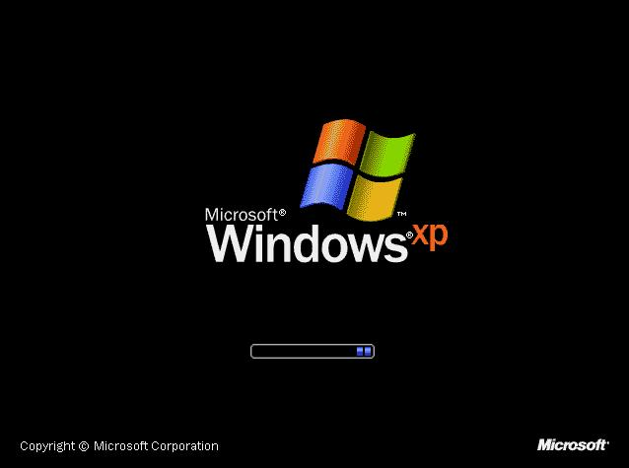

Windows XP lets many users to create their own accounts, with optional passwords, Each account contains all the settings that the account’s user likes, such as screen colors, start menu options, and other preferences. When someone first starts the computer, a welcome screen appears with each user’s account name and an associated icon. See figure. From the list of available users, click the user account with which you want to log on. For Example, click second name icon for WEB.

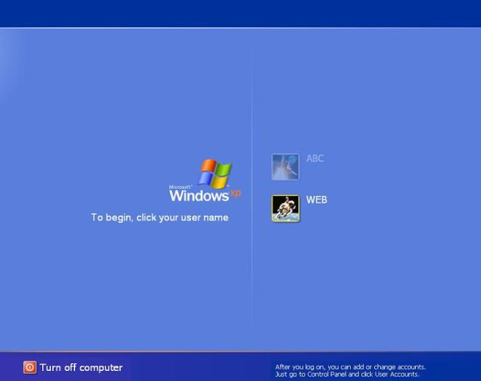

***Basic Windows Elements***

The different icons of the Windows XP opening screen are as shown in above figure and discussed in the following paragraphs.

***The Desktop***

The Desktop is the work area on a Windows screen where you are made to work. It is called the Desktop because Windows uses your whole screen in a way that is similar to the way you use the top of your desk. As you work in Windows, you move items on the Desktop retrieve and put away items and perform many other day-to-day tasks.

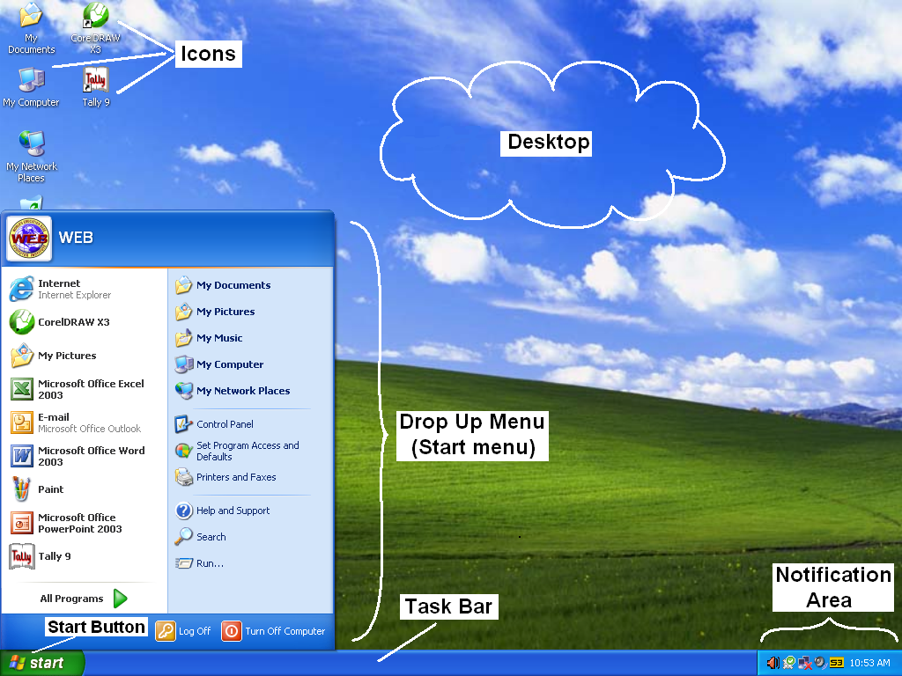

***Icons and their Types***

An icon is a graphic object that shows a program or a file on your desktop or monitor. The different types of icons are described in the successive sub-sections.

* ***System Icons***

System icons are displayed along left edge of the screen. These objects are created automatically by Windows during its installation. The five system icons are explained in the following.

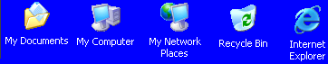

* ***Shortcut Icons***

These are the icons with small arrows in the lower left corner. A shortcut icon provides easy access to some objects on your system, such as a program, a document, or a printer, etc. The shortcut icon only contains information about the location of the object but not the object itself.

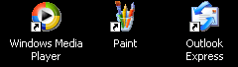

* ***Program, Folder and Document Icons***

These are non-system icons without arrows and they represent the actual objects they describe.

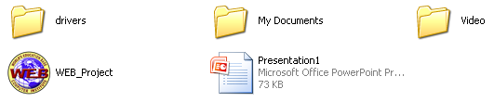

***The Taskbar***

Along the button of the screen as seen in following figure is the Taskbar. The taskbar can also be displayed along the side or the top of the screen.

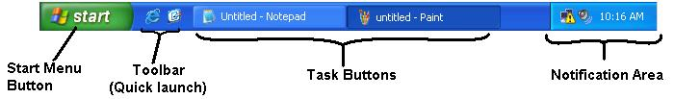

The different parts of the taskbar as in figure are explained in the following ways.

**Start Menu button**

It is located at the left end of the taskbar. Clicking the start button bring up the Start menu called Popup menu.

**Toolbars**

Toolbar represent a set of related icons for an easy access of mouse. For example, the quick launch toolbar provides icons for launching Internet Explorer and Outlook Express. Windows provides several toolbars which you can use as per your convenience.

**Task Buttons**

Task buttons are displayed in the center portion of the Taskbar. A button appears for each program you have started or each document you have opened. You can click these buttons to move from one open Program or folder to another.

**Notification area**

The right corner of Taskbar has the notification area in which Windows provides information about the status of your system. To see the description of icon appearing in the notification area, position the mouse pointer on the icon.

***Start Menu***

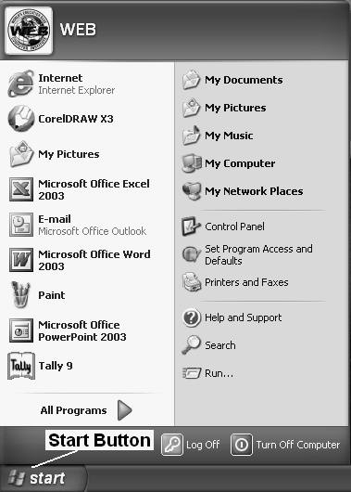Start menu appears when you click on Start button on the Taskbar as see in the figure. The Start Menu provides you with more customization options. It shows you who is logged on. It automatically adds the most frequently used programs to the top-level menu. It enables you to move any programs you want to the Start menu. Items such as My Pictures and My Documents folders and Control Panel are also now available on the Start Menu.

***Types of Files***

Everything on your computer is made up of files on your hard disk. Windows itself is just thousands of different files that interact with one another. The applications you use from day to day are also collections of many files that interact with one another and with Windows files. All the documents you create are themselves files that are loaded by the applications you use to create them. For example, when you save a Document in MS Word, that document is saved as file on your disk.

**Working with Files and Folders**

Files and Folder are two fundamental concepts of the Windows operating system. You create and organize files and folders as soon as you save your work in a PC.

**File**

A file is any collection of related information that is given a name and stored on a disk so that it can be read and manipulated whenever required.

**Folder**

As you work in Windows, you would see that hard disk contains hundreds of files even before you start creating your own file. It would be impossible to keep track of all these files if they are not arranged properly. In Windows, the fundamental device for managing files is a folder.

A folder can be either open or closed. When it is closed, all you see is its name and the folder icon. When a folder is open, it has its own window, and the files contained in the folder are shown in the window.

**Application Software**

Application software is sets of one or more programs designed to carry out operations for a specified application.

Example a word processing is the software which is used to process text. It allows the user to enter, view, edit, manipulate, transmit, store, retrieve and print text material. The text material may be letters, reports, notes, thesis, book, invoices, projects or anything else.

Notepad, WordPad, Paint, Microsoft Word, Microsoft Excel, Microsoft Power Point, Internet Explorer, etc. are the Application Software Examples.

**Input / Output Devices**

To communicate with the computer system we require some kind of Input/output devices. Input device is used to feed data into the computer system and Output device is required by the computer to communicate the result to the user.

**Input Device**

The devices which are used to give instructionsinto the computer system are called “Input devices”.

i.e. Keyboard, Mouse, Mic, Scanner.

***Keyboard:***

Keyboard is the main Input device of the computer; wecan’t operate other devices without Keyboard.

In normal Keyboard 101/ 104 Keys are present. Computer keyboard is similar to the typewriter Keyboard, So that a traditional typist can use the computer keyboard without any trouble.

In Market many types of keyboards are available depends upon connectors & depends upon keys.

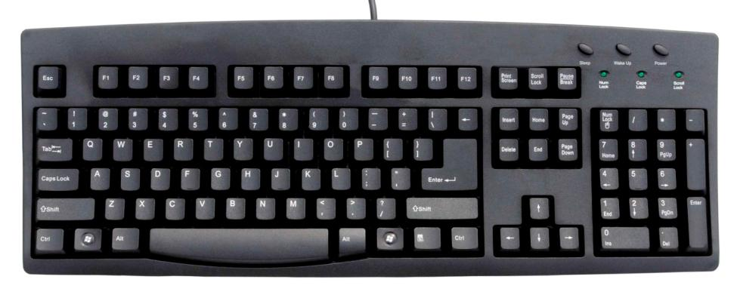

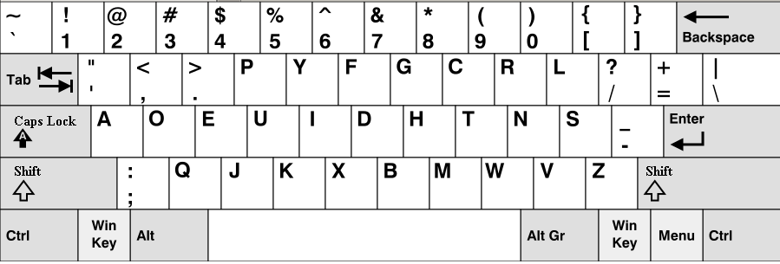

**Types of keyboards**

(According to Connectors)

* AT/XT Connector Keyboard
* PS/2 Connector Keyboard
* USB Connector Keyboard
* Wireless / Cordless Keyboard.

1. **AT/XT Connector Keyboard**

It is very old types of connector Keyboard

It is 5 pins DIN connectors

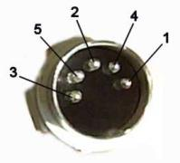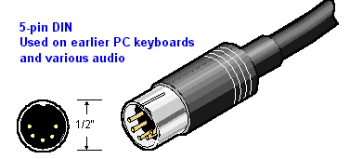

1. **PS/2 Connector Keyboard**

It is old type of connector keyboard.

It is 6 pins mini-DIN connector keyboard.

It is mostly in purple color.

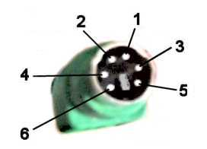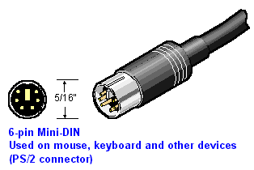

1. **USB Connector Keyboard** (Universal Serial Bus)

It is also new type of connector keyboard.

It is rectangular metal shape with plastic coated cover.

It is 4 pins connector.

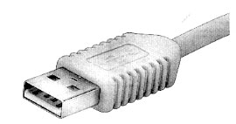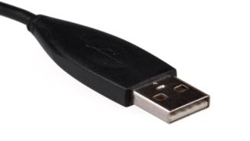

1. **Wireless or Cordless Keyboard**

It is latest USB technology types of connector keyboard.

The wireless keyboards communicate with the receiving unit connector to the main system unit. Its receiving unit connected to the computer CPU with USB connector.

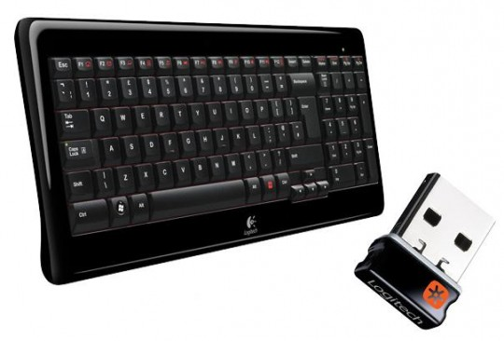

**Types of keyboards**

(According to Keys)

* 101/104 Keyboard
* Windows 95/98 enhanced Keyboard
* Multimedia enhanced Keyboard
* Internet enhanced Keyboard

**Note: -** To run the multimedia or internet enhanced keyboard in windows 95/98 normally we have to install drivers (software) which comes along with the keyboard.

***Mouse:***

A mouse is basically a pointing device. that functions by detecting two-dimensional motion relative to its supporting surface. Physically, a mouse consists of an object held under one of the user's hands, with one or more buttons. It sometimes features other elements, such as "wheels", which allow the user to perform various system-dependent operations, or extra buttons or features that can add more control or dimensional input. The mouse's motion typically translates into the motion of a pointer on a display, which allows for fine control of a graphical user interface.

The “Mouse” is basically made for “Graphical User Interface” application. The mouse can never replace the keyboard, but it can supplement the keyboard by doing tasks such as moving the cursor and pointing to on-screen objects.

It got its name because the wire coming out of the end of the first computer mice reminded people of the tail of a real mouse. Many mice today are wireless and use batteries.

The first known publication of the term mouse as a pointing device is in Bill English's 1965 publication "Computer-Aided Display Control".

The online Oxford Dictionaries entry for mouse states the plural for the small rodent is mice, while the plural for the small computer connected device is either mice or mousses.

A computer mouse is used to tell a computer what to do, including moving the cursor and choosing things on the screen.

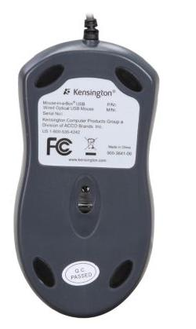

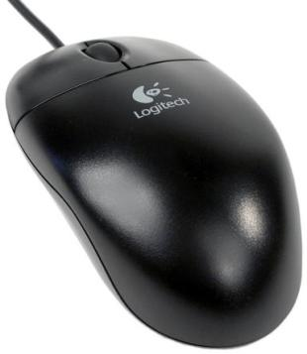

In market many types of mouse, some depends upon connector& some depends upon technology.

**Types of Mouse**

(According to connector)

* Serial Connector Mouse
* PS/2 Connector Mouse
* USB Connector Mouse
* Wireless/cordless Mouse

1. **Serial Connector Mouse**

It is very old type connector Mouse.

It is D shape connector Mouse.

It is 9 pins connector Mouse

A serial port is the most common method of connecting a mouse, a serial mouse is connected to either COM1 or COM2 i.e. to any one of the available serial port on the computer.

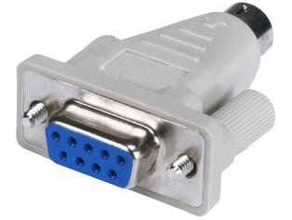

1. **P/S 2 Mouse**

It is old type of connector mouse.

It is 6 pins mini-DIN connector.

It is mostly in Green color.



1. **USB Connector Mouse**

The USB port can be used to connect a mouse.

As the mouse is not required during power on/Boot up process, no special BIOS is required for handling USB mouse.





1. **Wireless Mouse**

In this type of mouse everything is similar to the conventional mouse except that no cable is used to connect the mouse to the computer system.

Basically there are two types of wireless mouse.

* Infrared wireless Mouse.
* Radio-Controlled wireless Mouse.

The infrared mouse communicates with the receiving unit connected to the main system unit using infrared light. When the Radio-controlled wireless mouse is moved radio signals are transmitted by it to a special receiver unit connected to the main system.

Most of the infrared wireless Mouse and Radio-Controlled Wireless Mouse require the mouse to be within six feet of the receiving unit.

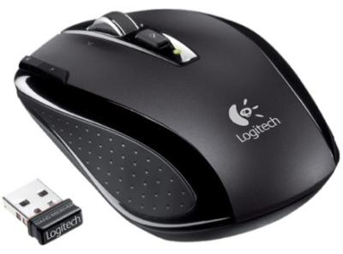

**Types of Mouse**

(According to technology)

Based on the technology used to detect the mouse movement, mouse can be divided into following categories.

* Mechanical Mouse
* Opto-Mechanical Mouse
* Optical Mouse
* Laser Mouse

1. **Mechanical Mouse**

A mechanical mouse works by the mechanical action of its various parts. When this mouse is rolled across a flat surface different rollers inside the mouse move and generate electric signals.

These signals are given to the computer and computer converts them into proper action on the screen.

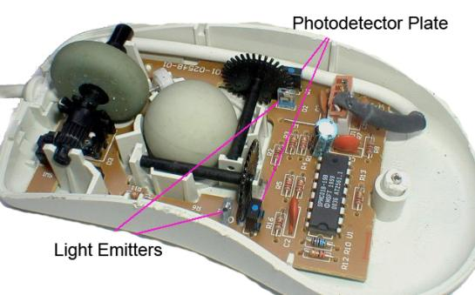

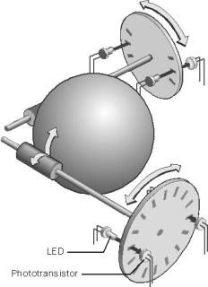

1. **Opto-Mechanical Mouse**

Basic construction of the Opto-Mechanical Mouse is same as that of the mechanical mouse only difference is in the sensing circuit used to detect the movement of the mouse.

In a mechanical mouse a decoder is used to detect the distance mouse is moved on the tabletop, whereas in a Opto-Mechanical mouse a combination of LED(Light Emitting Diode) and photo detectors is used to sense the distance traveled by the mouse.

1. **Optical Mouse**

The new optical mouse is a small computer in itself. It contains a full pattern-recognition Hardware/software in its digital processor IC.

This pattern-recognition capability allows the new option mouse to be used on any surface without the need to use any special mouse pad.

As the mouse is moved, it compares the image of the previous position stored in its memory. The difference between two images inform about the direction, the mouse is moved.

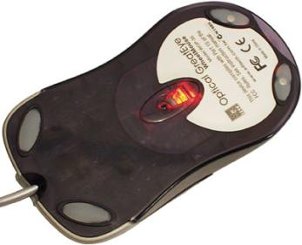

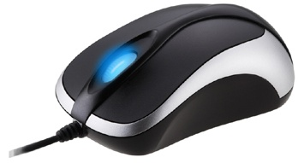

1. **Laser Mouse**

The laser mouse uses an infrared laser diode instead of a LED to illuminate the surface beneath their sensor. As early as 1998, Sun Microsystems provided a laser mouse with their Sun SPARCstation servers and workstations. However, laser mice did not enter the mainstream market until 2004, when Paul Machin at Logitech, in partnership with Agilent Technologies, introduced its MX 1000 laser mouse. This mouse uses a small infrared laser instead of a LED and has significantly increased the resolution of the image taken by the mouse. The laser enables around 20 times more surface tracking power to the surface features used for navigation compared to conventional optical mice.

***Microphone***

This device is used to record sound, speech etc. in computer system. It converts the voice signal into electronic signal most MIC comes along with the voice controller.

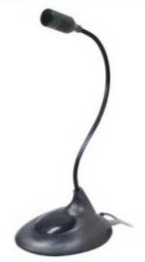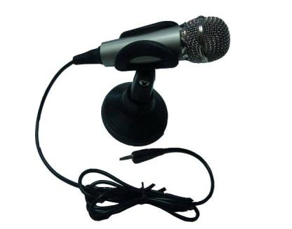

***Digital Camera***

Digital camera can be used to capture any image and to save them on storage device such as Hard disk, CD-ROM, Mobile Memory Card etc; these images can be posted on the web or printed on a color Laser/Ink-jet printer.

Some common Digital Camera,

* Digital Still Camera
* Digital Video Camera
* Web Camera

1. **Digital Still Camera**

Digital Still Camera look like the older film based camera. To use it one need to look through the view-finder, set the image, and push a button to take the picture.

Currently most of the Digital Still Camera provides high resolution images which can be printed to 8 inch × 10 inch size without any lose of image quality.

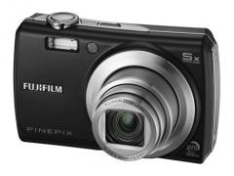Depending on the memory available to the camera, one can store from a dozen to hundreds of image into it.

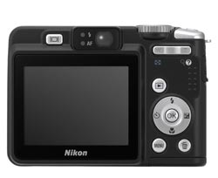

1. **Digital Video Camera**

Digital Video Camera is used to capture moving images digitally; they provide an images capture rate of around 30 frames per second. Resolution of this camera is lower than the resolution of Digital Still Camera. Most of Digital Video Camera provides 30 frames per second video at VGA mode, i.e. 640×480 pixels. Most of the Digital Video Camera provides zoom up to 30×. They can be used as a Digital Still Camera; they can also be used as a web camera.

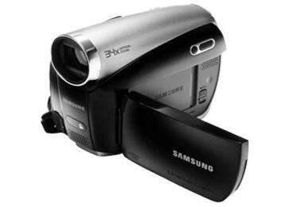

1. **Web Camera.**

A Web camera is basically a low-end Digital Video Camera with low resolution and fixed focus lens. This Camera is suited for web casting Video Messaging etc. applications.

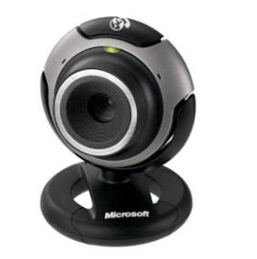One can use the Web Camera to make low- grade movies and capture still images.

***Scanner***

Scanner is used to input a photograph or any other existing drawing, sketch etc. into the computer.

The Scanner is a photograph like device, which scans the image put onto it and sends the image into the computer. Once the image is scanned into the computer, you can manipulate the image using graphic manipulation software such as CorelDraw, Adobe Photoshop etc.

Types of Scanner,

* Flat Bed Scanner
* Sheet Feed Scanner
* Handy Scanner
* 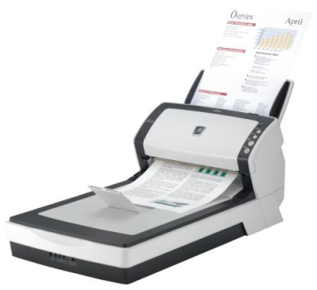Drum Scanner

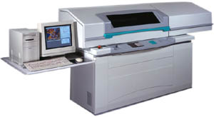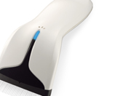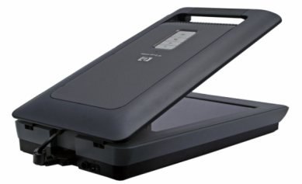

**Output Device**

When we enter the data through Input device into the computer system, it process in CPU (microprocessor) then we get result (output) by Output devices.

For example Monitor, Printer, Speaker, etc.

***Monitor***

Monitor is an Output device. It gives us result (Output) in the form of “Soft copy” with the help of software.

Monitor is the most common device used with a computer to display results

It has two Cables on back side.

**Power Cable (3 pins cable)**

One Female Connector Cable

2nd is Male connector cable

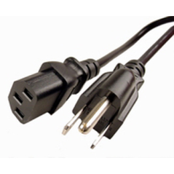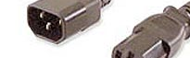

**Display Signal (VGA) cable (15 pins cable)**

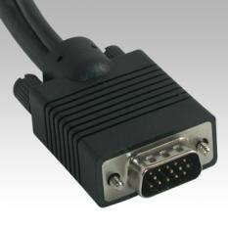

Monitors are of two types

* **CRT Monitor**
* **LCD Monitor**

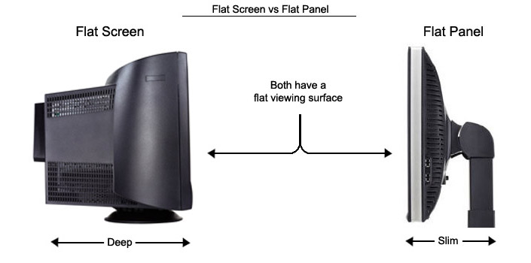

***CRT Monitor***

CRT Monitor stands for “Cathode Rays Tube” Monitor. The main unit in the CRT monitor is a picture tube. This tube is an evacuated glass tube with a phosphor coating (Phosphorus are material that glow when they are struck by electrons) on the inner front surface.

CRT Monitor is available on various different sizes & types for example 15” inch, 17” inch, 20” inch etc.

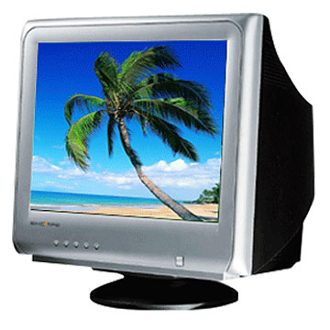

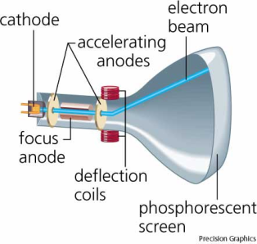

***LCD Monitor***

LCD Monitor stands for “Liquid Crystal Display” Monitor. Liquid Crystal Displays are non-emissive type display devices.

A non-emissive display does not produce any form of light like a Cathode Ray Tube (CRT) or Picture Tube. “Liquid Crystal” is neither liquid nor solid.

LCD Monitors are available in various different sizes,

For example 15” inch, 17” inch, 19”inch.

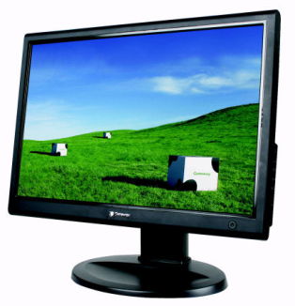

***Printer***

It is an Output device. It gives us result (output) in the form of “hard copy” (paper print out).

The printer is used to get a hard copy of result, i.e. it provides permanent output.

Printing mechanism refers to the method used by the Printer to produce the image on the output media, such as Paper, OHP transparency (over head projector) etc.

Based on the printing mechanism, printers can be classified into two groups

* Impact Printer
* Non-impact Printer

**Impact Printer**

Impact printer as the name suggests, these printers head physically make contact with the paper to create an image on it.

Using this property impact-printer can print multipart forms.

They can print not just through a ribbon but also through several sheets of paper and carbon sheet to print multiple carbon copies in a single pass.

Impact-printers are they produce too much noise during operation.

Impact-printer’s speed measured in CPS (Character per Second) or LPM (Line per Minute).

Types of impact printers,

* Dot-Matrix Printer
* Chain Printer

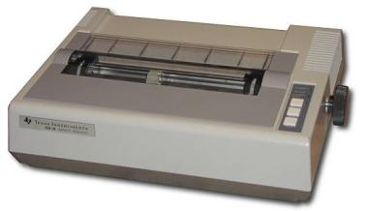

**Non-Impact Printer**

Non-impact printer’s head physically does not make contact with paper.

Non-impact printers do not strike any ribbon to produce the image, instead they use ink spraying electrostatic magnetization or heat process to produce the required image

Soundless operation and very high quality output of these printer.

They can’t be used to print carbon copies or multiple copies in a single pass.

Non-impact printer’s speed measured in PPM (Paper per Minute)

Types of Non-impact printer,

* Inkjet Printer
* Laser Printer

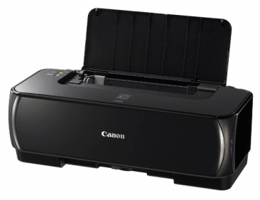

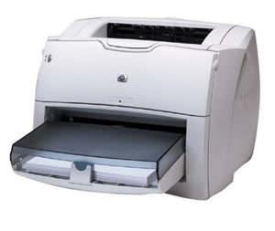

***Speaker***

Speaker an output device they are in various difference types of speaker available in market some are simply multimedia speakers some comes along with woofer system.

Using proper cable speaker output can be connected to an audio, amplifier or home stereo system to produce high volume sound output.

Some speaker classified into this type,

Normal Speaker,2.1 Speaker,5.1 Speaker, 7.1 Speaker etc.

Normal Speaker 2.1 Speaker 5.1 Speaker

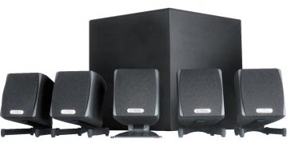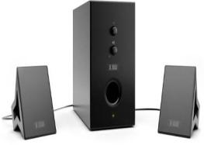

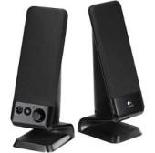

**Memory**

In computing, memory refers to the physical devices used to store programs (sequences of instructions) or data (e.g. program state information) on a temporary or permanent basis for use in a computer or other digital electronic device.

In Computer many types of applications are their, for all these applications we have to execute some program or set of instructions.

Before executing the program, it is stored into the computer memory and from the memory; computer takes program instructions one by one and execute them.

Program is executed are also kept in the computer’s memory before transferring them onto some other permanent storage device or an out put device.

**Memory**

**Primary**

**Memory**

**Secondary**

**Memory**

Floppy Disk

Hard Disk

Compact Disk

Pen Drive

**Permanent**

**Memory**

(ROM)

**Temporary**

**Memory**

(RAM)

1) PROM

2) EPROM

3) EEPROM

1) Synchronous RAM

2) Asynchronous RAM

3) Pipeline Burst RAM

**1) SRAM**

(Static RAM)

2) R DRAM

(Ram bus DRAM)

1) FPM DRAM

(Fast page Mode DRAM)

3) S DRAM

(Synchronous DRAM)

4) EDO DRAM

(External Data out DRAM)

5) DDRDRAM

(Double Data Rate DRAM)

**2) DRAM**

(Dynamic RAM)

6) DDR 2 DRAM

(Double Data Rate 2 DRAM)

7) DDR 3 DRAM

(Double Data Rate 3 DRAM)

The computer memory can be of two types based on the whether the memory is inside the computer or it is an external storage device.

* **PRIMARY MEMORY**
* **SECONDARY MEMORY**

**Primary Memory**

The main memory or the memory on the mother board is called the Primary Memory.

This primary memory can be further divided into twotypes.

* **RAM**
* **ROM**

***RAM***

* RAM is stands for Random Access Memory.
* A Random Access Memory also called as Read/Write Memory,
* RAM is Temporary Memory.
* It can read the information stored inside the RAM as well as write or store information into it.
* RAM is a type of memory which is used by the computer to store temporary values, program, data, etc.
* RAM is Volatile Memory.
* The Volatile Memory is a temporary memory which loses its content when the power supply to the memory is switched off.

There are two types of RAM

* **SRAM (Static RAM)**
* **DRAM (Dynamic RAM)**

***SRAM***

* SRAM stands for Static Random Access Memory.
* SRAM is costlier than DRAM.
* SRAM is much faster than the DRAM.
* SRAM does not require any refresh circuits.

***DRAM***

* DRAM stands for Dynamic Random Access Memory.
* DRAM is cheaper than the SRAM.
* DRAM is slow memory as compare to SRAM.
* DRAM uses a special refresh circuits.

***ROM***

* ROM is stands for Read Only Memory.
* ROM is a memory that can be read only, one can’t write any information into it.
* ROM is a Permanent Memory.
* Information is stored into the ROM by the manufacturers. Based on the method used to write into the ROM.
* ROM is Non-Volatile Memory.
* A non- volatile memory is a permanent memory, which does not lose its content even when the power supply is switched off.
* A non-volatile memory such as ROM is used inside the computer to keep permanent information, such as boot program, which is required each time the machine is switched on.

ROM can be classified into three types.

* **PROM (Programmable ROM)**
* **EPROM (Erasable Programmable ROM)**
* **EEPROM (Electrically Erasable Programmable ROM)**

***PROM***

* PROM stands for Programmable Read Only Memory.
* It is ROM with a small difference.
* At the time of manufacturing, this chip is made as a blank ROM chip and later using special PROM programmers the information is stored intothem.
* Once some information is stored into the PROM by “burning” the information into it, it becomes a ROM.

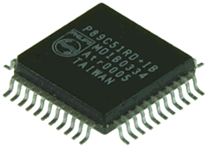

***EPROM***

* EPROM stands for Erasable Programmable Read only Memory.
* EPROM is easily distinguishable from other chips because of a small window in the middle of this chip. Thiswindow is covered with a transparent quartz glass. Through this window, ultra violet light can be shined on the EPROM to erase its content. Once the EPROM is erased it can be reprogrammed only once time using the EPROM programmers.

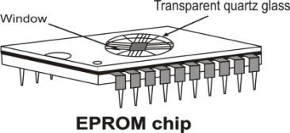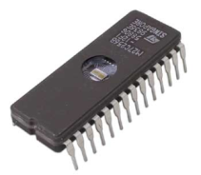

***EEPROM***

* EEPROM stands for Electrical Erasable Programmable Read only Memory.
* It is another type of EPROM.
* The difference between an EPROM and EEPROM is in the way its content is erased.In an EPROM the content is erased by shining ultraviolet rays through the window directly to the circuits, whereas in the EEPROM the content is removed by using electricity.

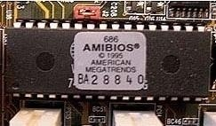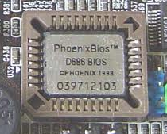

***Physical Memory Organization***

Initially the memory used inside the computer came in as separate DIP chips and earlier PCs were designed with sockets on their motherboard to accept these chips.

The memory module is a set of RAM chip on a single plug-in circuit board.

The memory modules are available in the following packing.

* DIP (Dual In-line Package)
* SIPP (Single In-line Pin Package)
* SIMM (Single In-line Memory Modules)
* DIMM (Dual In-line Memory Modules)

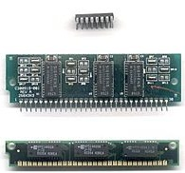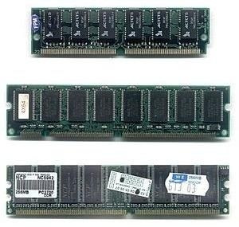

***DIP (Dual In-line Package)***

DIP or Dual Inline Package was used to be the most common packing for the memory chips; it resembles a small flat, rectangle box with metal legs on both sides.

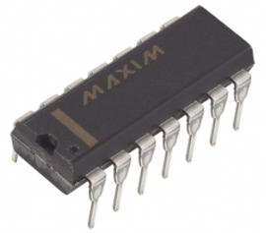

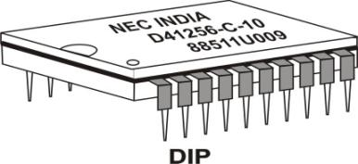

***SIPP (Single In-line Pin Package)***

SIPP or Single In-linePin Package contains pins at the bottom to connect them into the memory socket on the motherboard.

Most of the time these SIPPs are directly solder onto the motherboard rather then inserting them into the socket.

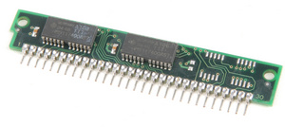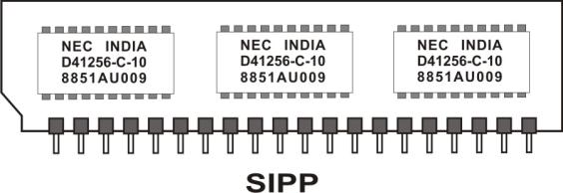

***Add/Remove SIPP***

To remove a SIPP module, one can just pull the SIPP module from both sides using even force and remove it from the socket.

To insert a SIPP module into its socket, first place the module in proper orientation on the socket and slowly press both sides down using even force, this should fix the module into the socket.

***SIMM (Single In-line Memory Modules)***

SIMM or Single In-line Memory Module is a number of memory chips soldered onto a small expansion board. The edge connector of this expansion board is plugged into a special SIMM sockets on the motherboard.

This design allows the memory to be added and removed from the computer without the risk of destroying it. Just like the discrete memory chips, the memory modules also come in different capacities.

First SIMM has 20 pins then it has 30 and 72 pins.

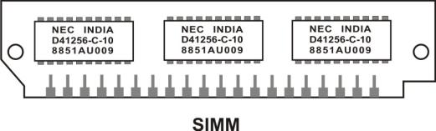

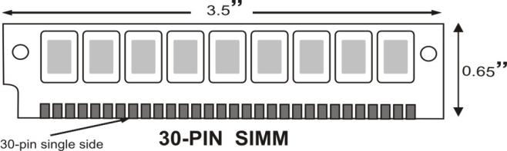

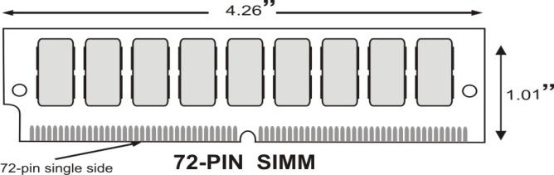

There are many different types of RAM which have appeared over the years and it is often difficult knowing the difference between them both performance wise and visually identifying them. This article tells a little about each RAM type, what it looks like and how it performs.

***FPM RAM***

FPM RAM, which stands for “Fast Page Mode RAM is a type of Dynamic RAM (DRAM). The term “Fast Page Mode comes from the capability of memory being able to access data that is on the same page and can be done with less latency. Most 486 and Pentium based systems from 1995 and earlier use FPM Memory.

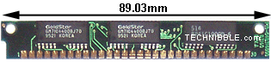

***FPM RAM***

***EDO RAM***

EDO RAM, which stands for “Extended Data Out RAM came out in 1995 as a new type of memory available for Pentium based systems. EDO is a modified form of FPM RAM which is commonly referred to as “Hyper Page Mode. Extended Data Out refers to fact that the data output drivers on the memory module are not switched off when the memory controller removes the column address to begin the next cycle, unlike FPM RAM. Most early Pentium based systems use EDO.

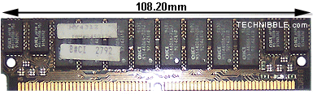

***EDO RAM***

***Add/remove SIMM***

Inserting and removing the SIMM module in the socket is very easy.

The SIMM is hold in the place by two metal or plastic clips on the both sides.Two latching holes in the module are also fixed on small round tabs on the socket.

To remove the modules, move the clips away from the module and push the module out of the tab, this will free the module, now pull it out.

To insert the module place it on the socket and press from both ends until the tab is in the hole and the clips have locket the SIMM into the tab.

***DIMM (Dual In-line Memory Modules)***

DIMM has 168 and 184 pins.

Two rows of edge connectors, one on each side of the module, are divided into three groups with short gaps between. The first group runs from pin 10; the second group from pin 11 to pin 40; and the third group from pin 41 to pin 84. Pin 85 is opposite pin 1.

Notches in the edge connector of the DIMM prevent one from sliding smaller SIMMs with less connection into a DIMM socket.

Some DIMM holes to allow you to latch the modules into their socket, although some DIMM lack these holes.

To accommodate the larger edge connectors and provide greater storage capacity, DIMMs are physically large, about 5.25 inches wide and typically one inch tall.

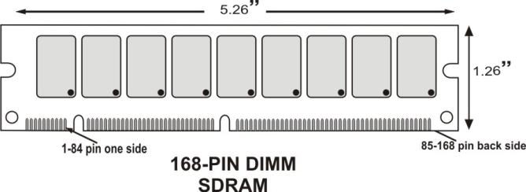

**SDRAM**

SDRAM, which is short for Synchronous DRAM, is a type of DRAM that runs in Synchronization with the memory bus. Beginning in 1996 most Intel based chipsets began to support SDRAM which made it a popular choice for new systems in 2001.

SDRAM is capable of running at 133MHz which is about three times faster than FPM RAM and twice as fast as EDO RAM. Most Pentium or Celeron systems purchased in 1999 have SDRAM.

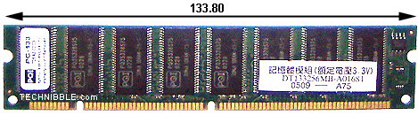  
***SD RAM***

***RIMM (Rambus In-line Memory Module)***

When Intel introduced Pentium 4 microprocessor, they wanted a very fast memory for it and there choice was RDRAM 0r Rambus DRAM memory.

RIMM is also Dual inline Memory Module.

Instead of using SIMM or DIMM, RDRAM comes in a special 184-pin RIMM, i.e. Rambus Inline Memory Module.

RIMM can not be used on the motherboards not designed for Rambus memory. Currently only Pentium 4 motherboard based on Intel 850chipset supports RIMM.

Even after its high speed operation, RIMM was not a success; the main reason behind its limited success was its cost.RIMM is very costly memory modules.

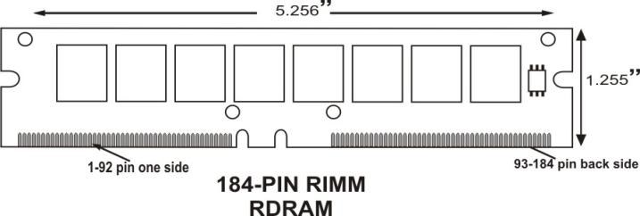

***DDR DIMM***

A much cheaper Double Data Rate (DDR) SDRAM provides speed almost equal to the RDRAM.

DDR SDRAM is costlier than standard SDRAM but it is much cheaper than the RDRAM.

DDR DIMM uses a connector with 184-pins. This connector contains a single notch near the center of the connector.

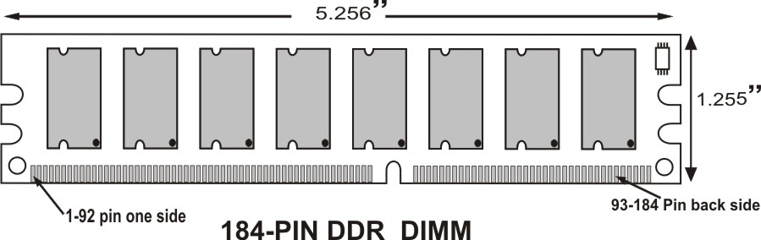

**DDR2 DIMM**

A much cheaper Double Data Rate 2 (DDR 2) SDRAM provides speed almost equal to the RDRAM and DDR SDRAM

DDR 2 is much cheaper than the DDR SDRAM.

DDR 2 has a connector with 240-pins.

It is same like DDR SDRAM with a small difference between notches place.

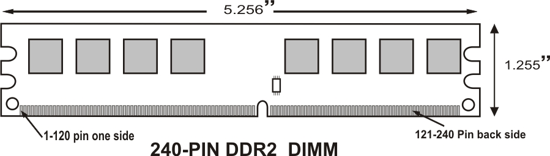

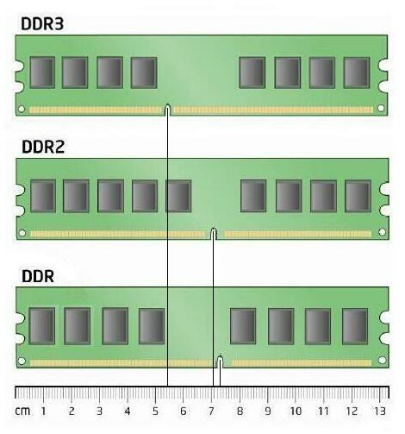

**Secondary Memory**

* **Floppy Disk (FD)**
* **Compact Disk (CD)**
* **Digital Versatile Disk (DVD)**
* **Hard Disk (HD)**
* **Pen Drive**
* **Hard Pocket Drive**
* **Mobile Memory Card**

The device which is used to store data and programs permanently inside the computer is called “Storage Device”.

Secondary memory is storage device.

i.e. Floppy disk (FD), Compact disk (CD), Hard disk (HD), Pen drive.

|  |  |
| --- | --- |
| **Storage Capacity of Storage Device** | |
| CD | 700 / 800 MB |
| DVD | 4.7 / 8.5 GB |
| Floppy Disk | 1.44 / 2.88 MB |
| Hard Disk | 40 / 80 / 120 / 320 GB |
| Pen Drive | 1 / 2 / 4 / 8 / 16 / 32 GB |

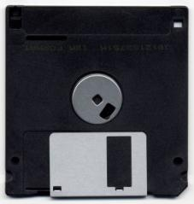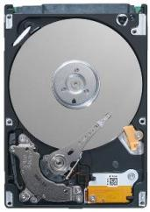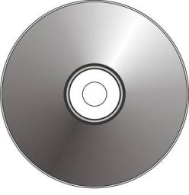

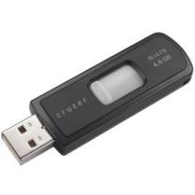

**CD / DVD- Rom Hard Disk Floppy Disk Pen drive**

**Floppy Disk**

A floppy disk is a disk storage medium composed of a disk of thin and flexible magnetic storage medium, sealed in a rectangular plastic carrier lined with fabric that removes dust particles. They are read and written by a floppy disk drive (FDD).

The Floppy Disk is a circulating shaped Mylar disk coated with some magnetizable compound. The disk is enclosed in a square protective case. A window is made on a case to provide a contact between read/write head and the disk.

The earliest floppy disks, developed in the late 1960s, were 8 inches (200 mm) in diameter; they became commercially available in 1971. These disks and associated drives were produced and improved upon by IBM and other companies such as Memorex, Shugart Associates, and Burroughs Corporation. The term "floppy disk" appeared in print as early as 1970, and although in 1973 IBM announced its first media as "Type 1 Diskette" the industry continued to use the terms "floppy disk" or "floppy".

Different sizes of floppy disks are fundamentally incompatible, and disks can fit only one size of drive. Drives with 3 1⁄2-inch and 5¼-inch slots were available during the transition period between the sizes, but they contained two separate drive mechanisms.

The first floppy disk was 8 inches in diameter, and was protected by a flexible plastic jacket. IBM used this size as a way of loading microcode into mainframe processors, and the original 8 inch disk was not field-writeable. Rewriteable disks and drives became useful.

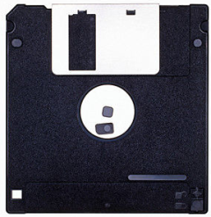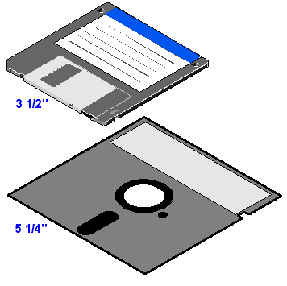

**Parts of the Floppy Disk**

The floppy disk stores information from computers and has two main parts: the protective components and recording components.

**Protective Components**

The protective components consist of the housing and shutter/spring.

***Housing***

A square protective outer plastic shell with two halves protects the inner contents of the floppy.

***Shutter and spring***

The shutter and the spring protect the information recorded on the disk. The shutter is a piece of metal over the housing. It slides over when inserted into the floppy drive, allowing access to the floppy and its contents. The spring closes the shutter once the disk is removed to keep fingerprints and dust off the floppy.

**Recording Components**

Several components inside the floppy relate to the recording process.

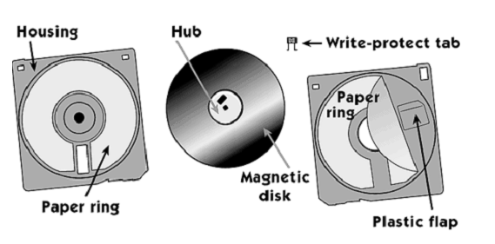

***Magnetic Disk***

The magnetic disk is a round piece of plastic coated with iron oxide, which can be magnetized. When you save information to a disk, a recording head creates a magnetic pattern on the iron oxide. This pattern stores your words or pictures in a form that the computer can read the next time you put the disk in. However, if the write-protect tab is open, you cannot save data. Computer can read the next time you put the disk in. However, if the write-protect tab is open, you cannot save data.

**Write-Protect Tab**

This little plastic rectangle is in the upper right corner of most disks. It slides up to reveal a square hole in the housing (or slides down, to cover the hole). When the hole is open, the disk is locked. Your computer won't allow you to add anything to the disk.

**Hub**

The center of the magnetic disk contains a metal hub containing holes. These holes fit over spindles inside the computer and hold the disk in place while it spins.

**Paper Rings**

The magnetic disk is sandwiched between two white paper rings. The two rings are glued down to the plastic housing and stay still while the disk spins. They clean the disk by removing microscopic bits of dust.

**Plastic Flap**

Under one of the paper rings is a plastic flap. One end is glued down, and the plastic isbent a little. Like a simple spring, it pushes the paper ring tight against the surface of theMagnetic disk.

**How a Floppy Disk Works**

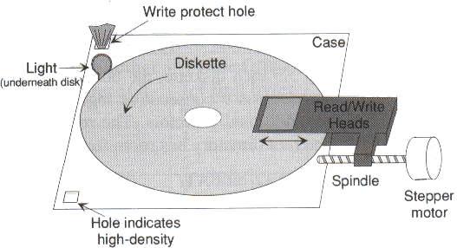

**Step 1: Exposing the Recording Surface:**

When you are insert the floppy disk into the drive, the shutter moves to the side to expose the magnetic recording surface on the disk.

**Step 2: Sending Signals from the Circuit Board**

Next, levers and gears move two read/write heads until they almost touch the magnetic disk on either side. These heads, which are tiny electromagnets, use magnetic pulses to change the orientation of metallic particles embedded in the disk's coating.

The floppy drive's controller board sends signals to the drive's circuit board, including data and instructions for writing data to disk. The circuit board then translates the instructions into signals to control the movement of the disk and the read/write heads.

**Step 3: Checking for Write Protection**

Next, the circuit board checks if the disk is write protected. If disk access is a write instruction, the circuit board verifies that light is not visible through the write-protect notch. If the notch is open and a beam from a light emitting diode can be detected, the drive knows the disk is write-protected and refuses to record new data.

**Step 4: Spinning the Disk**

Once the circuit board verifies that data can be written, motor located beneath the disk in the drive spins a shaft. The shaft then engages a notch on the disk’s hub, causing the disk to spin.

**Step 5: Positioning the Read/Write Heads**

Signals from the circuit board then direct a stepper motor, which can turn a specific amount in either direction. This motor positions the read/write heads over the correct location on the recording surface of the disk.

**Step 6: Writing the Data**

When the heads are in the correct position, electrical impulses create a magnetic field in one of the heads. Data is written to either the top or bottom surface of the disk. Instruction into signals to control the movement of the disk and the read/write heads.

***Drive Components***

* **R/W Head (Read/Write Head)**
* **Head Actuator/Stepper Motor**
* **Spindle Motor**
* **Circuit Board**
* **Cable Connector: - 34 pins data cable & 4 pins power cable**
* **Face Plate**
* **Disk Sensors**

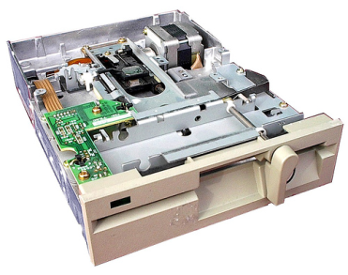

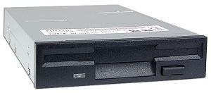

***R/W Head (Read/Write Head)***

This is a magnetic read/write head which reads from and write to the disk.

***Head Actuator/Stepper Motor***

This motor moves read/write head over the disk surface. This is a stepper motor, the stepper motor as their name suggests, works in steps.

***Spindle***

This is motor turns (rotates) the disk around by clamping the disk at the center. These drives always maintain a fixed rotation speed of 360-RPM (Rotation per Minute).

***Circuit Board***

It control read/write head, different sensors and other components on the drive.

***Cable Connectors***

34 pins data connector is used to carry the data and the control signal between the computer and the disk drive.

***Face Plate***

Faceplate, which is also called a “Bezel”; it is the plastic front cover of a disk drive.

***Disk Sensors***

Different types of sensors that are present inside the floppy drive are,

**Diskette Sensor: -** it senses the disk inside the drive.

**Write protect Sensor: -** it senses the disk either it is write-protected or not.

**Track Zero sensor (Boot Track): -** it sense the boot track from the disk.

**CD [Compact Disk]**

CD-ROM stands for “Compact Disk Read Only Memory”. CD-ROM is a polycarbonate plastic base disk.

It is 12-cm in diameter and can be used as storage purpose like Floppy Disk.It has many advantages compared with Floppy Disks, such as more storage capacity & cheapness.

CD-ROM is ideal for the distribution of computer software, data & also for multimedia and many more.

It has 700 MB (670 MB can store) of data storage capacity.

A compact disc [sometimes spelled disk] (CD) is a small, portable, round medium made of molded polymer (close in size to the floppy disk) for electronically recording, storing, and playing back audio, video, text, and other information in digital form. Tape cartridges and CDs generally replaced the phonograph record for playing back music. At home, CDs have tended to replace the tape cartridge although the latter is still widely used in cars and portable playback devices.

Initially, CDs were read-only, but newer technology allows users to record as well. CDs will probably continue to be popular for music recording and playback. A newer technology, the digital versatile disc (DVD), stores much more in the same space and is used for playing back movies.

***DVD-ROM***

DVD-ROM stands for “Digital Versatile Disk Read Only Memory” or “Digital Video Disk ROM”. It is a new development in the CD-ROM technology is multilayered DVD with still high storage capacity which people are already using.

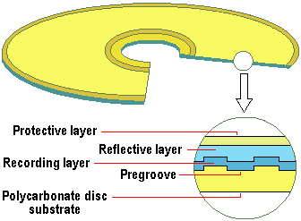Its storage capacity is 4.7 GB.

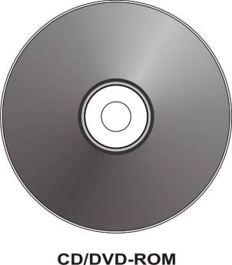

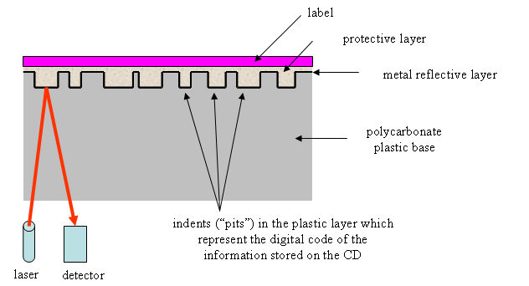

***Differences Between different sizes of disk.***

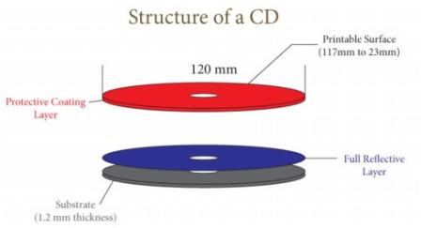

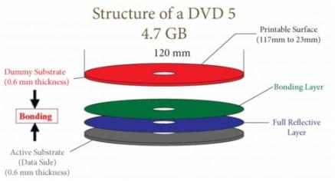

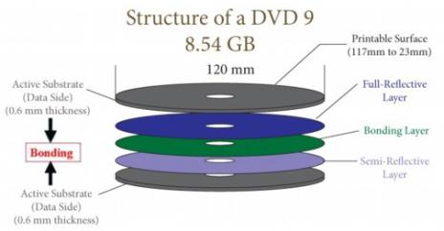

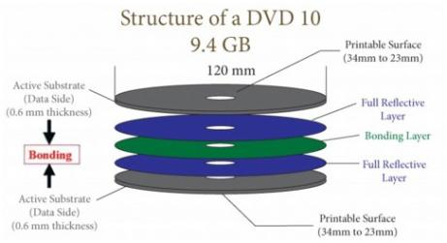

**Hard Disk**

Hard Disk Drives are the most common storage device used with the computer system. The Hard Disk Drive is also known as **Hard Disk, Hard Drive, Fixed Disk Drive or Winchester Disk Drive**.

The hard disk drive is used to store data and programs permanently inside the computer.

Information is stored in the hard drive using the magnetic recording method, which is used to store song on an Audiotape or movies on Videotape.

In market Hard disk drives are found on two categories,

* **PATA (Parallel Advanced Technology Attachment) / IDE Hard Disk**
* **SATA (Serial Advanced Technology Attachment) Hard disk.**

***PATA / IDE HARD DISK***

IDE is stands for “Integrated Drive Electronic”.

Around 1986, Compaq (Computer manufacturer) wanted to improve the ST-506/412 drive used in their system, for this they approached a hard disk drive manufacturer company called WD (Western Digital).

Currently most of the motherboard comes with connectors for IDE drives; one can directly connect the IDE drive to this connector using a 40-pins wire (IDE) cable. It is no longer than 18” inch.

On this hard disk have Jumper connector for Master setting Slave setting & 4 pins power connector to the power supply.

***SATA HARD DISK***

SATA stands for “Serial Advanced Technology Attachment”.It has 15 pins SATA Power cable & 7 pins SATA Data cable. It does not need any jumper setting.

Serial ATA was designed to replace the older parallel ATA (PATA) standard (often called by the old name IDE), offering several advantages over the older interface: reduced cable size and cost (7 conductors instead of 40), native hot swapping, faster data transfer through higher signaling rates, and more efficient transfer through an (optional) I/O queuing protocol.

As of 2009, SATA has replaced parallel ATA in most shipping consumer desktop and laptop computers, and is expected to eventually replace PATA in embedded applications where space and cost are important factors. SATA's market share in the desktop PC market was 99% in 2008. PATA remains widely use in industrial and embedded applications that use Compact Flash storage, though even there, the next CFast storage standard will be based on SATA.

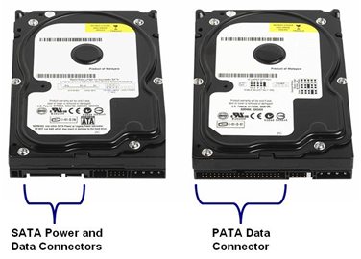

## Hard drive basics

The majority of hard drives use a rotating magnetic disk known as a platter to store data.  The actuator moves the arm from the outer rim of the platter to the spindle in order to position the head over the platter where data will be written or read.  When writing data, the head produces a magnetic field that magnetizes the surface of the platter to store data.  The magnetic fields produced by platter can also be read by the head to retrieve data.

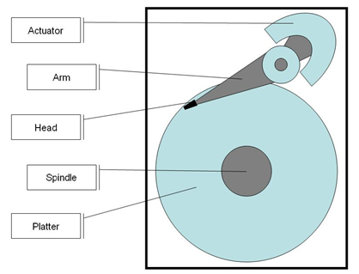

***Rotating magnetic hard drives store data on a magnetic platter by producing a magnetic field with the head.***

In order to increase data storage density, most hard drives contain more than one platter. The platters are stacked on top of each other. Each platter has a corresponding arm and head for writing and reading data.

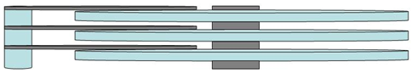

***Most hard drives contain more than one platter to increase data storage density.***

Solid-state is another type of hard drive.  Unlike rotating magnetic hard drives, solid-state hard drives contain no moving parts.  They are based upon flash memory, which stores data electrically using transistors.  We will discuss use cases for solid-state hard drives later in the white paper.

***More installation information***

There are currently two types of internal hard drive connection interface used in desktop PCs: SATA (serial ATA) and the PATA (parallel ATA, also known as IDE). The newer SATA standard brings new features and improved I/O throughput compared to IDE, as well as other differences:

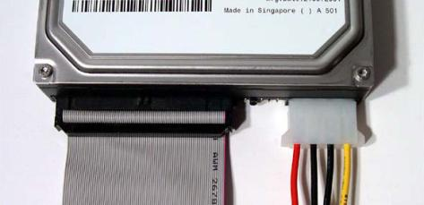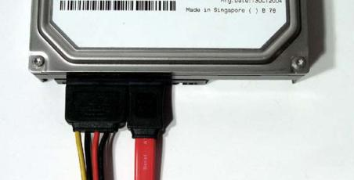

***Data cable***

The traditional IDE data cable consists of two or three 40-pin connectors, as well as a wide cable with 40- or 80-conductor inside (the IDE devices utilizing ATA 66, ATA 100 or ATA 133 interface must use the 80-conductor IDE cable). An IDE cable can be used to connect up to 2 IDE devices if there are three connectors present; one which is used to connect to the IDE port on the motherboard and other two the IDE ports on the storage devices.

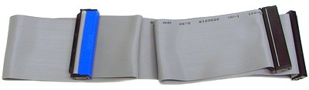

**IDE cable**

Compared to the IDE cable, the SATA cable is much thinner and simpler. The SATA cable features only seven pins for an easier connection. The slim design of the SATA cable promotes better airflow inside the case for improved temperature management. This is especially pronounced when there are 3~4 hard drives installed. A SATA cable is only allowed to connect to one SATA storage device.

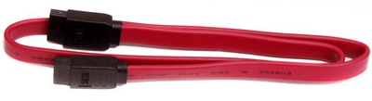

**SATA cable**

***Power cable***

IDE hard drives receive power through a 4-pin Molex connector, which typically provided in abundant numbers by most power supplies. The standard SATA power connector is a thinner but features more pins. Since the SATA power connector is unavailable on many power supplies, some SATA hard drives provide both the 4-pin Molex and SATA power connectors for flexibility. The 4-pin Molex to SATA converter cable is the other option.

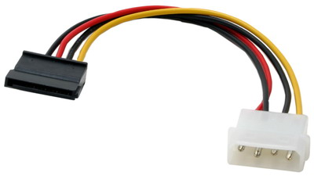

**4-pin Molex to SATA power converter cable**

***Back panel of hard drive***

On the back panel of an IDE (PATA) drive you will find, besides the power and data connectors, a set of jumpers which are used to set the hard drive to work in either master or slave mode. If you connect two hard drives (or a hard drive and another IDE device) on a single IDE cable, one of them should be set as master and the other as slave.

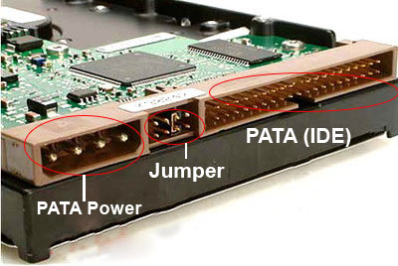

***IDE (PATA) hard drive***

Since one SATA cable will only connect to one SATA hard drive, there is no jumper for slave/master mode selection on the back panel of a SATA hard drive (some SATA 3.0 Gbps compliant hard drives may feature a jumper for SATA 3.0 Gbps / SATA 1.5 Gbps mode selection). Thus you may only find a SATA power and SATA data connector available at the back of your SATA drive. There are SATA hard drives that feature the IDE and SATA power connectors for flexibility. In these cases please connect only one of the power connectors to the power supply.

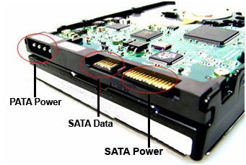

***SATA hard drive***

***Shock and Heat***

Hard drives tend to vibrate during operation if not securely fastened to the chassis. This is harmful to itself because it causes shock and may cause noise and annoyance to its user. Please securely fasten your hard drive to the 3.5” bay of your case for reduced vibration and noise.

Another issue is the heat that is produced during operation. Keeping your drive(s) cool by ensuring a steady flow of air or by promoting air flow by using a fan, or installing a hard drive cooler are all good ideas.

***Drive Components***

* **Disk Platter**
* **Read/Write Head**
* **Head Arm/Head Slider**
* **Head Actuator Mechanism**
* **Spindle Motor**
* **Logic Board**
* **Air Filter**
* **Cable & Connectors :- Data cable & Power Cable**

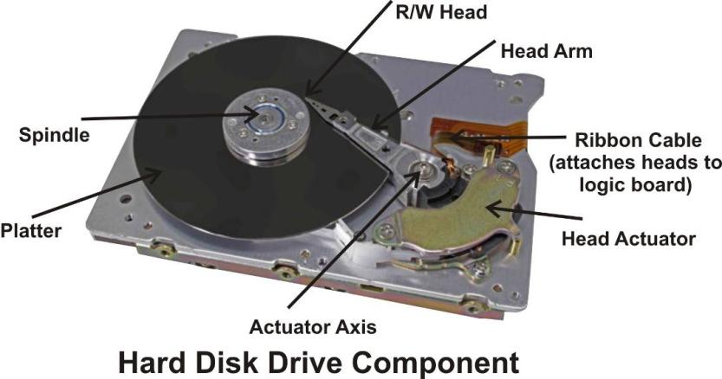

***Disk Platter***

Hard Disk Drive contains a number of platters or the circular shaped disks on which the information is magnetically recorded.

The platter size (i.e. the diameter of the platter) is called the form factor of the hard drive.

The hard drive size is measured by its platter’s diameter. There were many different platter sizes in use, some of the common platter sizes are;

***5.25” (Actually)***

***3.5” (Actually)***

***2.5”***

***1 1/8”***

***1 1/3”***

The 3.5”inch size platter is currently most common with the personal computers. 2 or 3 numbers of platter drive are most common.

***Read/Write Head***

Read/Write head is used to write any information on the disk surface and to read the written data, without any data loss. A hard disk drive contain for each side of its platter.For example if a drive contains 3 platters then total six read/write head will be used to read/write the top & bottom sides of each platter.

***Head Arm/Head Slider***

The arm on which the read/write head of the disk drive is located is called the head slider.Disk drive manufactures provide special textured patterns on the head slider surface to keep the slider at a constant height from the disk surface during the disk operation.

***Spindle Motor***

Spindle motor is the main motor which rotates the hard disk drive’s platters. It is called the spindle motor because this motor is directly connected to the spindle on which the platters are connected.Hard disk platters rotate at around more than 7200 RPM (Rotation per Minute).

***Logic Board***

The hard disk contains a logic board to control different parts of the hard disk drive. This logic board is also used to interface the hard disk drive with the computer.

***Head actuator Mechanism***

The read/write head of the hard disk drive is moved on the platter using different mechanism; this is referred as head actuator mechanism.

***Cable & Connectors***

Connectors are used to connect with cable to the hard disk & main system. Connectors are present on back side of the hard disk i.e.

**Disk Geometry**

The hard disk drive stores data as magnetic information on its surface.

To arrange the data properly on the disk surface, the disk surface it divided into different sections called Tracks, Sectors, Cylinders and Clusters etc.

When some information is written on the disk surface the computers writes it on some specific side on some specific tracks and sectors. Tracks and sectors are saved in an index like place called directory and FAT (File Allocation Table). From this information computer can get the stored data without any trouble.

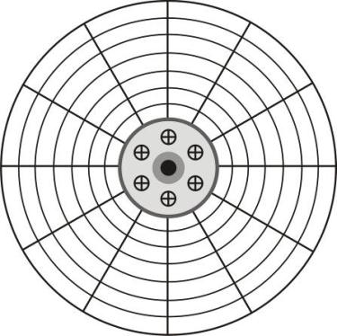

***Tracks***

Hard disk drives platter’s surface is divided into concentric circles, it is called “Tracks”.

The outer track is 0 track the next track is 1, next track 2 and so on. The inner most track will have the highest number.

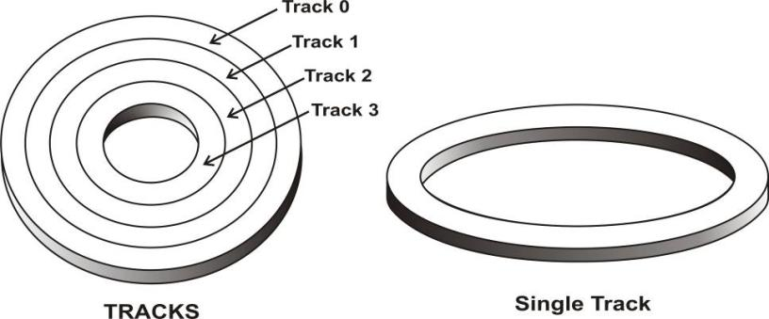

***Cylinder***

Hard disk drive has more than one platter; same tracks of different platters form an imaginary cylinder like structure.When data is stored on the hard disk drive, it is stored cylinder by cylinder.

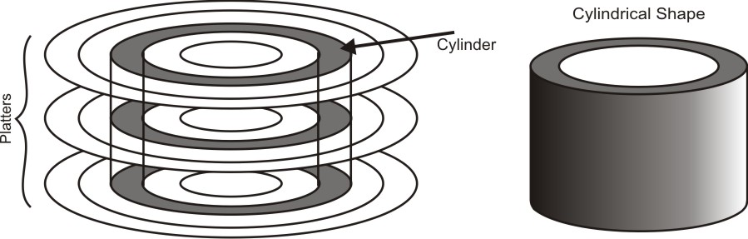

***Sector***

Different capacity of hard disk drive divides the track into different number of sector. Sector starts with number 1.

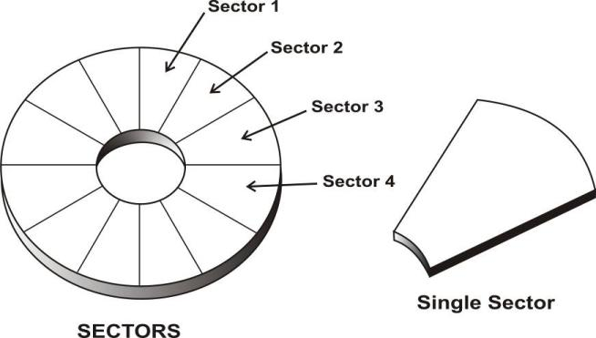

***Cluster***

When heads writes some information on the hard disk, it does not allocate the space sector wise, it uses a new unit of storage called “Cluster”.

If one cluster can store 512 bytes data then to store 513 bytes you will require two clusters.

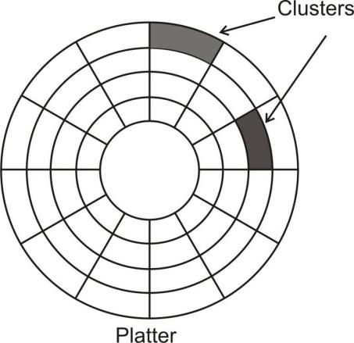

***Partition***

Partition is a new concept introduced by IBM when they launched the 10MB hard disk drives. At that time the 10 MB hard disk was considered very big storage area and they decided to use it for two different operating system DOS and XENIX, by dividing the drive into two logical parts or volumes. One part devoted for each operating system. Partition is also known as “Volume”.

This partitioning was necessary because the DOS and XENIX operating system used different file formats and both operating systems could not coexist on a single drive.

The partitioning of hard disk is required even if the hard disk is to be used as a single volume disk or for a single operating system.

DOS/Windows program FDISK.EXE is used to partition a hard disk drive. One should not experiment with this command because any change in existing partition will destroy the data stored on the hard disk drive.

***LOGICAL STRUCTURE OF A HARD DISK DRIVE***

It is the job of the DOS FDISK and FORMAT command to create these logical areas on the disk drive.

FDISK command creates Master Boot Record (MBR) and FORMAT command creates DOS Boot Record (DBR), FAT area, Root Directory area and the empty data area.

Logical Sector 1

on Drive D

Logical Sector 1

on Drive C

|  |  |  |  |  |  |  |  |  |  |  |
| --- | --- | --- | --- | --- | --- | --- | --- | --- | --- | --- |
| Physical Sector 1 | **Partition 1 (C: Drive)** | | | | | **Partition 2 (D: Drive)** | | | | |
| **DOS**  **Boot**  **Record** | **FAT1** | **FAT2** | **Root Directory** | **Data Area** | **DOS Boot Record** | **FAT1** | **FAT2** | **Root Directory** | **Data Area** |

**Logical Structure of Hard Disk Drive**

***(MBR) Master Boot Record / Partition table Record***

The MBR or Master Boot Record contains a small program to load and start the active/bootable partition. This area also contains information about all four primary partitions on the hard disk drive, their starting sector, ending sector, size etc. in a format known as “Partition Table Record”.

The master boot record is always located at cylinder 0, head 0, sector 1 and the partition boot sector are located at the beginning of each partition volume.

The maximum number of all type of partition together allowed by DOS is 24, this limitation comes from the fact that DOS uses a single upper case alphabet to name a partition, the first partition is given the name C and the last partition is given upper case letter Z, so from c to Z only 24 letter are available for assigning to the partition, because A & B already reserve for floppy drive.

***(DBR) DOS Boot Record / DOS Boot Sector***

First logical sector of each partition contain a volume boot sector. On DOS partition the hard disk drive contains DOS Boot Record (DBR) or DOS Boot Sector. The job of the DBR is to load the operating system (OS) from the hard disk drive into the computer’s main memory and give the system’s control to the loaded OS.

For this purpose the DBR contains a small program, this program is executed by the master boot record (MBR) program. It is the job of this Boot program to look for the two program files IO.SYS and MSDOS.SYS on the root directory of the partition.

If the IO.SYS and MSDOS.SYS programs are not available in the directory the directory then following message is displayed

“Non-System disk or disk error, press any key to Continue”

**Motherboard**

Motherboard is large circuit board in your computer system. It is the most important component in any personal computer. It contains almost every important parts of the computer system.

The Motherboard contains the CPU (Microprocessor), Memory (RAM, ROM) and support circuit to make the computer work.

Motherboard also contains many expansion slots on which we can connect various circuit boards these circuit boards are used to connect different devices such as Monitor, Printer, Scanner, etc. with the computer.

This main board is called the “Motherboard”because all other circuit boards, inside the computer are attached to this board i.e. it is the Mother of all boards. All other boards that attach to it are called “Daughterboard”.

Motherboard is inside the PC cabinet where different types of Bus, Slots, Connectors and other electronic component i.e. ICs, Capacitors, Resisters, etc.

In personal computers, a motherboard is the central printed circuit board (PCB) in many modern computers and holds many of the crucial components of the system, providing connectors for other peripherals. The motherboard is sometimes alternatively known as the mainboard, system board, and planar board or, on Apple computers, the logic board. It is also sometimes casually shortened to mobo.

***Position of the Motherboard***

Inside the main system unit position of the Motherboard depends on the model/type of the cabinet being used.

Inside a tower model cabinet the Motherboard is attached to one side of the system box normally. It is placed just below the power supply.

On a desktop model cabinet the Motherboard is placed at the base of the system box, next to the power supply.

Motherboard is connected to the cabinet with about ½ inch high plastic spacer in between the board and the cabinet all various places.

This protects the component on the Motherboard from touching the cabinet bottom metal surface and short circuiting themselves.

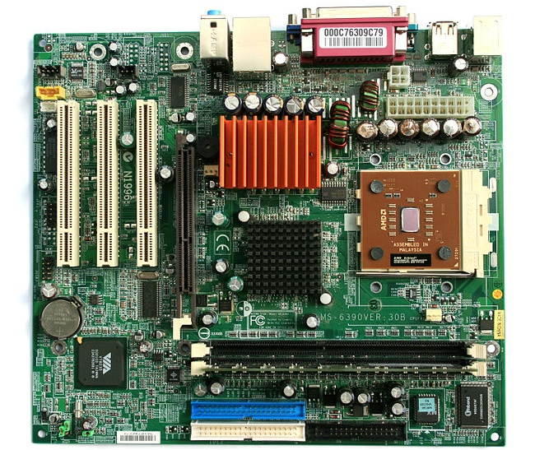

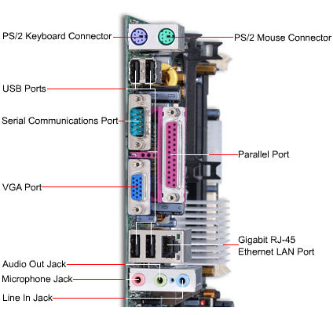

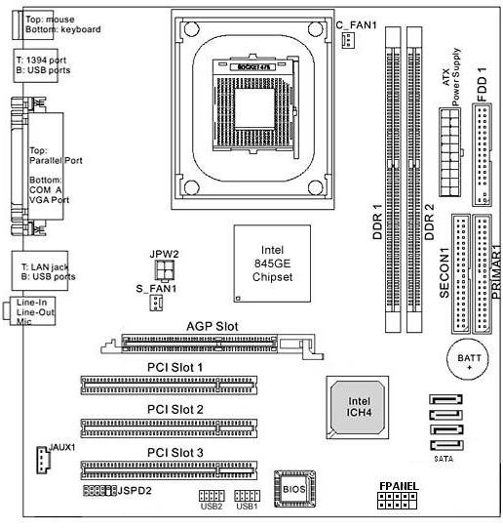

***BUS***

Bus is an electronic road along which signals are sending from one part of the computer to another computer.

The bus is a set of parallel copper connections on the computer’s motherboard. The bus is like a “High-Way” for the data.

Depending on their function, bus is divided into two types

* **Data Bus**
* **Address Bus**

**Data Bus**

The Data bus is used to move data from one place to another, the number of the data lines provided in the bus is very important factor that determines the speed of this data transfer.

**Address Bus**

The Address bus is used to select a particular memory location to read or write the data maximum memory that CPU can address depends on the size of its address bus.

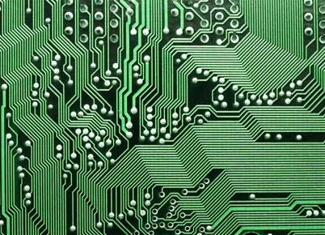

***Motherboard Components***

***CPU (Microprocessor)***

The main component of any motherboard is the main processor chip which controls the inner functions of the system. The Central Processing Unit (CPU) is brain of PC.

CPU is usually inserted into the socket and is not soldered onto the motherboard; this makes its replacement in case of any problem or for upgrade very easy.

Some of the common CPU chips are Intel 8085, 8086, 8088, 80286, 80386,80486, Pentium, Pentium MMX, Pentium-II, Pentium-III, Pentium-4, Pentium Dual Core, Pentium Core 2 duo, AMD Athlon XP, AMD Athlon MP, AMD Duron.

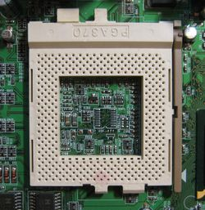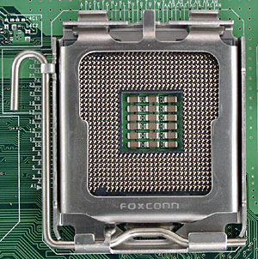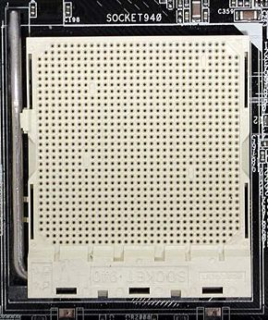

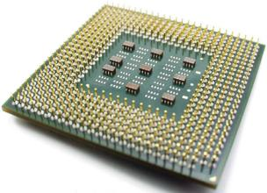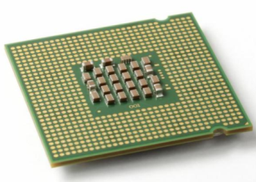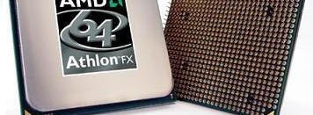

***Some Common Processor***

***8088/8086/8085***

8088 processor was the first CPU used in the IBM PC Computers; its clock speed was 4.77 MHz.

The 8088 chip comes in a 40-pin DIP (Dual Inline Package).

8088 processor can access 1 MB (Mega Byte) of Memory.

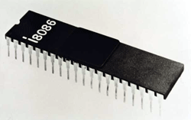

***Pentium/P5/80586***

Pentium, P5 or 80586 is the next processor from the Intel.

Intel could not copy right numeric name such as 80586, 8088 so they decided to call their next processor “Pentium”.

This word Pentium comes from the Greek word Pente, which means Five.

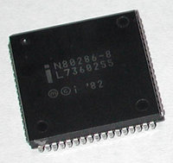

***Pentium MMX***

Pentium MMX processor offers higher performance compared to the original Pentium Processor. MMX stands for Multi Media Extension.

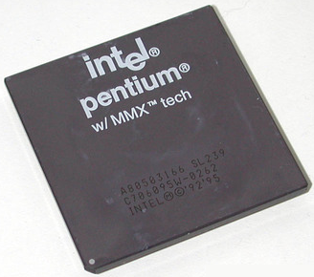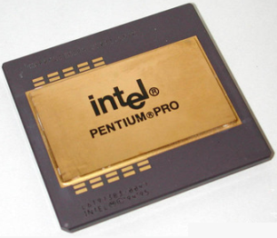

***Celeron Processor***

The Intel Celeron processor offer great performance at an exceptional value for today’s applications.The Intel Celeron processor at speed ranging from 600 MHz to 2.06 GHz expands Intel processing performance into the value-priced PC market segment.

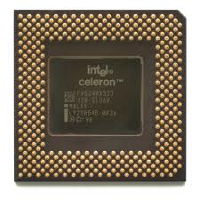

***Pentium-II Processor***

The Pentium-II processor is at 450 MHz Intel’s high performance desktop processor.The Intel Pentium-II processors deliver excellent performance for all PC software and are fully compatible with existing DOS and windows based software.

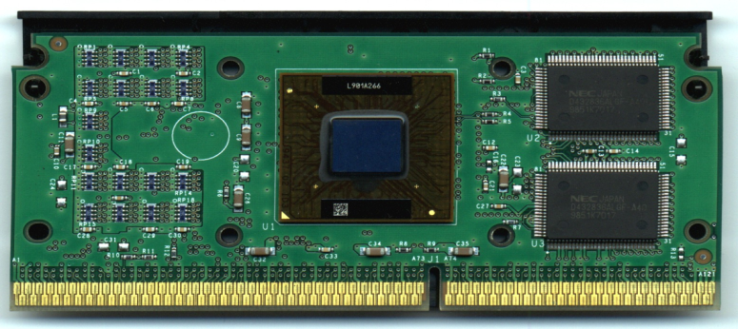

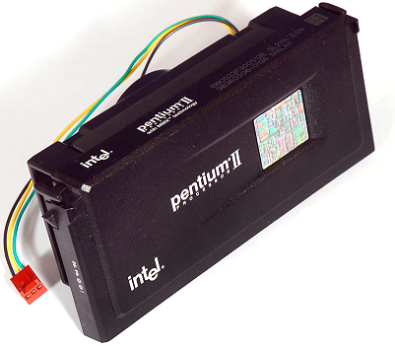

***Pentium-III Processor***

The Intel Pentium-III processor is a top performance for mainstream business and consumer desktops.The Pentium-III processor is available at speeds ranging from 450 MHz to 1-2 GHz.

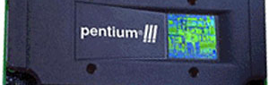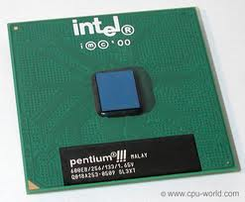

***Pentium 4 Processor***

The Intel Pentium 4 processor Intel’s most advanced, most powerful processor is based on the new Intel Net burst micro-architecture.

This processor is designed deliver performance across applications. These applications include internet audio and streaming video, image processing, video content creation, speech, 3D, CAD, Games, Multimedia, and multi tasking user environments.

The Intel Pentium 4 is available at speeds ranging from 1.3 to 3.6 GHz.

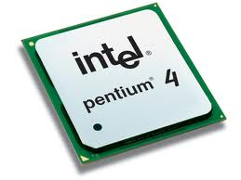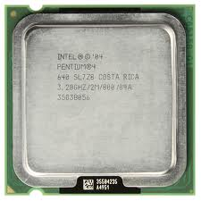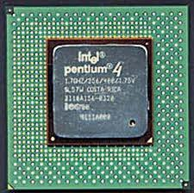

***Intel Xeon Processor***

The Intel Xeon processor is ideal for compute intensive and heavy workload applications that require floating point performance and the intense use of graphics for design.The Intel Xeon processor is available at speeds 1.40 GHz and higher.

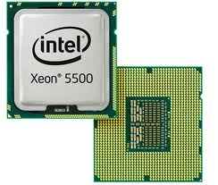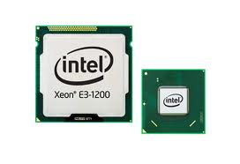

***AMD Microprocessor***

Intel microprocessor were the first choice with most of the PC compatible computer manufacturers, but slowly some new companies such as AMD are providing cheaper and better alternative to the Intel microprocessor.Next types of Athlon is

* Basic Athlon
* Athlon 4
* Athlon XP
* Athlon MP

Athlon 4 is basically the same basic Athlon with a new name; Athlon XP was introduced by AMD with the introduction of windows XP according the AMD, Athlon XP is better suited to run windows XP operating system

Athlon MP is specially made for servers and MultiProcessing applications.

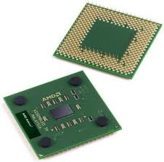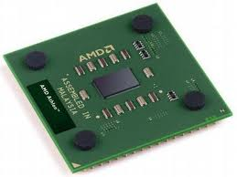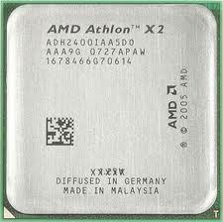

***AMD Duron***

AMD Duron is a lower priced version of the Athlon processor. Duran is placed against the Intel Celeron processor.

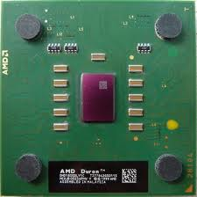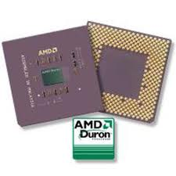

**BIOS**

BIOS is stands for Basic Input Output System. In computer system BIOS is a ROM chip (BIOS chip on the motherboard is ROM chip).

It is a set of programs stored inside a ROM chip and put on the motherboard. The main job of the program stored into this ROM to take care of input/output from different input, output and storage devices connected to the computer.

This BIOS ROM is always available in the computer, so any user program can access these routines for their input/output requirements.

The first PC BIOS was made by the IBM for their PC range of computer. The BIOS program being the copyright property of the IBM Corporation, PC compatible makers use the BIOS made by AMI Award, Phoenix,Quadtel, etc.

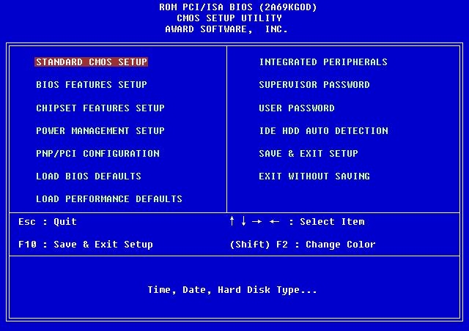

BIOS is the acronym for Basic Input Output System and it is pronounced “Bye-OS”. It is a program stored inside a PROM chip on your computer.

This program lets your operating system and application programs communicate with computer hardware and peripheral devices such as Floppy disk, Hard disk,Printer, Display adapter, etc.

Reading the keystroke, displaying on the screen, reading/writing of the serial & parallel port, reading/writing to and from the floppy & hard disk etc. is done under the control of the BIOS.

BIOS contains two more modules.

* **POST**
* **Bootstrap loader**

***POST (Power On Self Test)***

When you switch on your system, it runs a series of diagnostic tests, collectively called the Power-on Self-Test (POST). POST makes sure the following computer parts are functioning properly:

Keyboard, Power supply, System board, System memory, Memory modules, Controllers, Graphics system, Diskette drives, Hard drives.

POST also detects the type of mass storage devices installed in the computer. If POST finds an error in the system, it reports the error condition by an audible Beep Code and/or visual message. Once POST is complete it will proceed to the BIOS startup screen.

When the computer is first powered on, POST program checks the processor memory, support circuits and other devices connected to the computer system.

If this routine finds any error or fault during this POST, the error is informed to the user as an error beep or as some error message on the screen. Some errors called non fatal-errors allow user to continue, whereas fatal errors will not allow the POST to continue until the program is rectified.

Once the POST routine is executed successfully, BIOS goes to the boot process.

***Award BIOS***

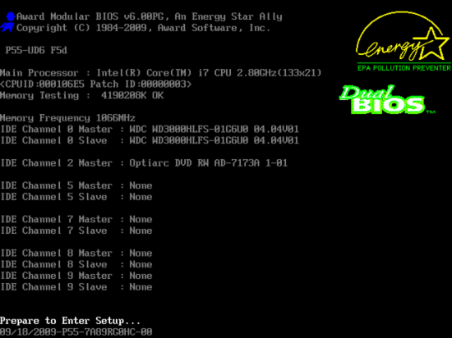

***Phoenix BIOS***

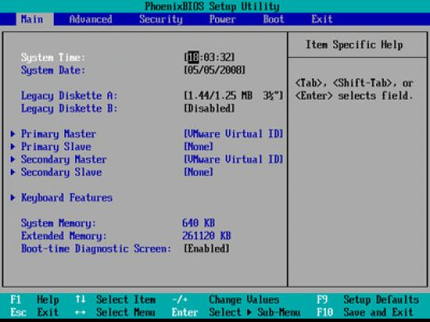

***Bootstrap Loader***

After the POST routine, BIOS continues with a program called “Bootstrap Loader”.It is the job of bootstrap loader to load the (OS) Operating System from the floppy disk, hard disk, CD-ROM or any other storage device into the computer main memory (RAM).

Unless the bootstrap loader is completed successfully i.e. the OS is copied from storage device to the main memory, that time user can’t use the computer.

A successful transfer of the OS into the RAM or the boot process is indicated by displaying the DOS prompt such as A:\> or c:\> on the computer monitor.

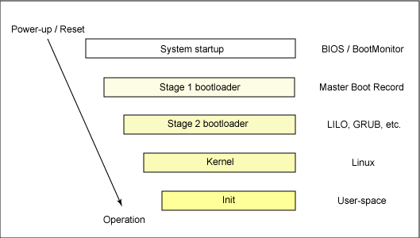

***Some Common Question about BIOS***

***Q: What is BIOS?***

A: BIOS stands for Basic Input Output System.

All computer hardware has to work with software through an interface. The BIOS gives the computer a little built-in starter kit to run the rest of softwares from floppy disks (FDD) and hard disks (HDD). The BIOS is responsible for booting the computer by providing a basic set of instructions. It performs all the tasks that need to be done at start-up time: POST (Power-On Self Test, booting an operating system from FDD or HDD). Furthermore, it provides an interface to the underlying hardware for the operating system in the form of a library of interrupt handlers. For instance, each time a key is pressed, the CPU (Central Processing Unit) perform an interrupt to read that key. This is similar for other input/output devices (Serial and parallel ports, video cards, sound cards, hard disk controllers, etc...). Some older PC's cannot co-operate with all the modern hardware because their BIOS doesn't support that hardware. The operating system cannot call a BIOS routine to use it; this problem can be solved by replacing your BIOS with an newer one, that does support your new hardware, or by installing a device driver for the hardware.

***Q: Well, I see that the BIOS is necessary for the computer, but what can I do with it?***

A: You can change hardware configurations that are stored in the CMOS, or Complementary Metal Oxide Semiconductor.

To perform its tasks, the BIOS need to know various parameters (hardware configuration). These are permanently saved in a little piece (64 bytes) of CMOS RAM (short: CMOS). The CMOS power is supplied by a little battery, so its contents will not be lost after the PC is turned off. Therefore, there is a battery and a small RAM memory on board, which never (should...) lose its information. The memory was in earlier times a part of the clock chip, now it's part of such a highly Integrated Circuit (IC). CMOS is the name of a technology which needs very low power so the computer's battery is not too much in use.

Your PC's performance can be highly affected by the CMOS settings. The reason for this is that the CMOS setup allows you to specify how fast your computer reads from memory, whether or not your cache is enabled or disabled, whether or not your CPU's cache is enabled or disabled, how fast your PCI bus communicates with its adaptor cards, plus a lot more. For more information on optimizing these performances settings/  
Additionally, the CMOS setup allows you to specify disk drive and memory configuration. In order for your hard drive to work with your system, it must be configured in the CMOS setup. The exception to that rule is SCSI drives with adaptor cards, as most have their own built in BIOS. Floppy drives can be setup in the CMOS as well; a: can be made to be b: in many systems, and other configuration options can be changed as well.

***Q: So how do I change the configuration that is saved in the CMOS?***

A: By utilizing a set of menus called the CMOS Setup.

Setup is the set of procedures enabling the configure a computer according to its hardware characteristics. It allows you to change the parameters with which the BIOS configure your chipset. The original IBM PC was configured by means of DIP switches buried on the motherboard. Setting PC and XT DIP switches properly was something of an arcane art. DIP switches/jumpers are still used for memory configuration and clock speed selection. When the PC-AT was introduced, it included a battery powered CMOS memory which contained configuration information. CMOS was originally set by a program on the Diagnostic Disk, however later clones incorporated routines in the BIOS which allowed the CMOS to be (re)configured if certain magic keystrokes were used.  
Unfortunately as the chipsets controlling modern CPUs have become more complex, the variety of parameters specifiable in SETUP has grown. Moreover, there has been little standardization of terminology between the half dozen BIOS vendors, three dozen chipset makers and large number of motherboard vendors. Complaints about poor motherboard documentation of SETUP parameters are very common.

To exacerbate matters, some parameters are defined by BIOS vendors, others by chipset designers, others by motherboard designers, and others by various combinations of the above. Parameters intended for use in Design and Development, are intermixed with parameters intended to be adjusted by technicians -- who are frequently just as baffled by this stuff as everyone else is. No one person or organization seems to understand all the parameters available for any given SETUP.

***Q: Now that I know where to edit the CMOS options, how do I access this CMOS setup on my computer?***

A: By entering a keystroke combination when the system is first booted.

When the system is powered on, the BIOS will perform diagnostics and initialize system components, including the video system. (This is self-evident when the screen first flicks before the Video Card header is displayed). This is commonly referred as POST (Power-On Self Test). Afterwards, the computer will proceed its final boot-up stage by calling the operating system. Just before that, the user may interrupt to have access to SETUP.  
Usually, setup can be entered by pressing a special key combination (DEL, ESC, CTRL-ESC, or CTRL-ALT-ESC) at boot time (Some BIOSes allow you to enter setup at any time by pressing CTRL-ALT-ESC). The AMI BIOS is mostly entered by pressing the DEL key after resetting (CTRL-ALT-DEL) or powering up the computer. You can bypass the extended CMOS settings by holding the key down during boot-up. This is really helpful, especially if you bend the CMOS settings right out of shape and the computer won't boot properly anymore. This is also a handy tip for people who play with the older AMI BIOSes with the CMOS setup. It allows changes directly to the chip registers with very little technical explanation.

**Chipset [North-South Bridge]**

All the diverse support functions inside a PC were integrated into a few VLSI components individually termed Application Specific Integrated circuit or ASICs these ASIC are collectively called chipset

Current motherboard provide by the support chips on a set of chips (ICs) known as chipset. These chipsets are made by various motherboard manufacturers, such as

Intel-810 chipset,

Intel-845 chipset,

Via-915 chipset,

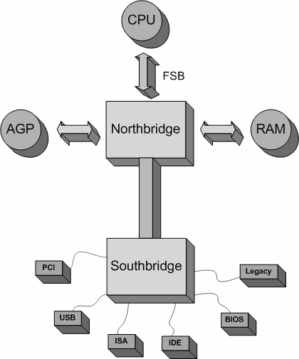Via-945 chipset &

Opti

The chipset normally consists of two major microchips. These are known as the North Bridge and the South Bridge. Developments in chip technologies have meant that chipset and CPU manufacturers are changing the way the chipset layout works, for example some CPU's come with a built in memory controller taking that job from the North Bridge, some chipsets have incorporated the north and south bridge in the same chip, but for now we will look at the standard setup.

The **North Bridge** Handles data for the graphics port whether that is AGP or PCI express and the main memory which includes the FSB (Front side bus). Although both chips are required for the PC to work the North Bridge handles most of the very important tasks such as the connection between the CPU and main memory bank. The **South Bridge** handles data from the PCI x1 slots and can also have integrated components such as Audio and/or onboard graphics.

The North and South bridges will have different chip names even though they are very often paired with the same opposite bridge to come under the collective name of the chipset. Below is a diagram of the KT600 chipset from VIA technologies. This diagram shows how the components of your PC are connected to the chipset.

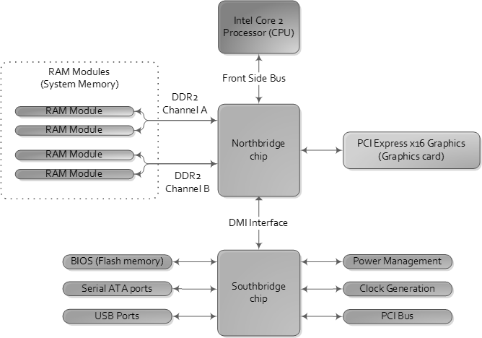

**CPU Support Chips**

With the CPU Memory, motherboards also contain some support chips or ICs. These chips help the CPU in carrying out its various activities.

Some of the common support chips are DMA controller (Direct Memory Access), Interrupt Controller, Keyboard Controller, Timer, etc.

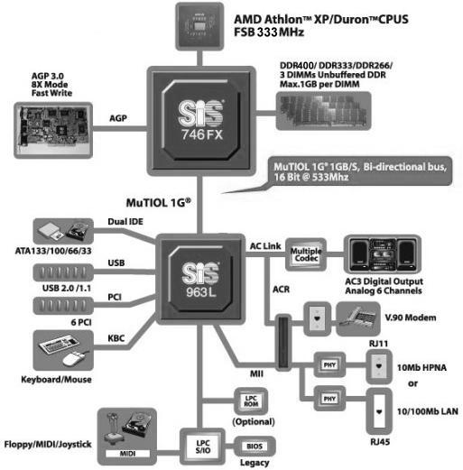

**CMOS Battery**

CMOS is stands for “Complimentary Metal Oxide Semiconductor” with battery backup to store the system configuration date, time etc.

The battery inside the PC keeps the clock working when the main power supply to the system is switched off, so that the next time when you switch on the system you will get correct time.

When the system is switched on BIOS matches the information stored inside the CMOS with the components connected to the system and if it finds some error, the BIOS displays error message explaining the problem.

Presently 3V, Lithium battery is commonly used in most of the motherboard.

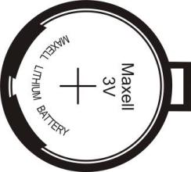

**Memory Slots**

The physical memory is installed on the memory slots of the motherboard. Different types of motherboard have different types of memory slots, like

**SIMM (Single Inline Memory Module)**

In this 20pins, 30 pins & 72 pins memory can be installed i.e. EDORAM, FPMRAM.

**DIMM (Dual Inline Memory Module)**

In these168 pins (SDRAM), 184 pins (RDRAM & DDRRAM) & 240 pins (DDR2& DDR3) can be installed.

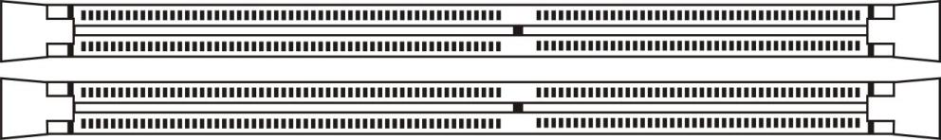

**VGA / Display Port**

VGA is stands for “Video Graphic Adaptor”.

It is 15 pins Port on motherboard.

It is D shape female connector.

It is mostly in blue color.

It is interface between CPU to Monitor.

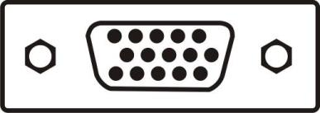

**PS/2 Port**

On motherboard two types of PS/2 ports.

* **PS/2 Keyboard port**
* **PS/2 Mouse port**

Keyboard port is in Purple color &Mouse port is in Green color.

***PS/2 connector***

The PS/2 connector is a 6-pin Mini-DIN connector used for connecting some keyboards and mice to a PC compatible computer system. Its name comes from the IBM Personal System/2 series of personal computers, with which it was introduced in 1987. The PS/2 mouse connector generally replaced the older DE-9 RS-232 "serial mouse" connector, while the PS/2 keyboard connector replaced the larger 5-pin/180° DIN connector used in the IBM PC/AT design. The PS/2 designs on keyboard and mouse interfaces are electrically similar and employ the same communication protocol. However, a given system's keyboard and mouse port may not be interchangeable since the two devices use a different set of commands.

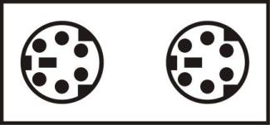

**Serial Port**

Serial port is used for Mouse & Modem.

It is 9 pins serial connector.

It is D shape connector.

Normally it is present in either COM1 or COM2.

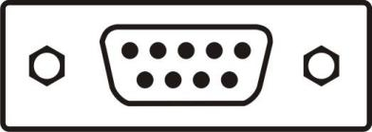

**Printer Port / LPT Port**

LPT port is stands for Line Printer Terminal.

LPT port also known as printer port or parallel port.

It is very old types of port

It is 25 pins port.

It is mostly in pink color.

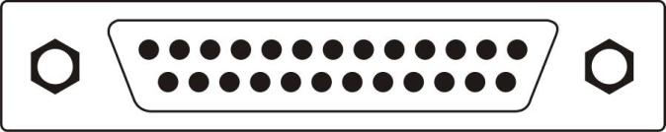

**USB Port**

USB is stands for **“Universal Serial Bus”** port.

It is 4 pins connectors.

It is new types of connector that can run any devices with this port without restarting computer.

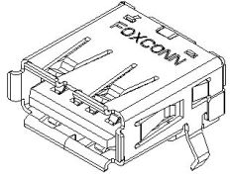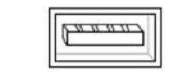

**LAN Port**

It is RJ 45 connector port.

It is 8 pin ports. Using this port we can share our data to another computer.

With the help of this port we can join computer to Local Area Network.

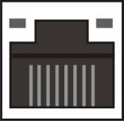

**Audio Port**

It is three types of port

* **Speaker port**
* **Microphone port**
* **Audio in (Line-in) port**

Speaker port is mostly in green color,

Microphone port is in red color &

Line-In port is in blue in color.

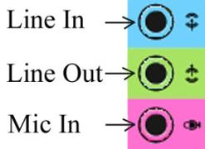

**FDC Connector**

FDC is stands for **“Floppy Drive Connector”**.

It is 34 pins connectors on the motherboard.

It is used to install Floppy Drive.

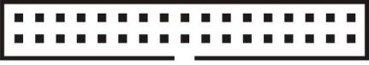

**IDE Connector**

IDE connector is stands for **“Integrated Drive Electronic”**.

IDE is also known as PATA (Parallel Advanced Technology Attachment).

It is 40 pins connectors.

It is used for CD-ROM drive & Hard disk drive.

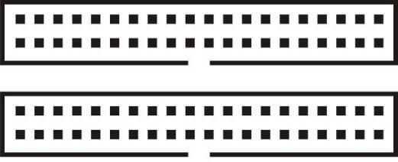

**SATA Connector**

SATA means “Serial Advanced Technology Attachment”.

It is 7 pins connectors.

It is used for CD-ROM drive & Hard disk drive.



**Expansion Slots**

The motherboard contains many expansion slots, long narrow connector towards the back of the computer. On these slots different expansion cards can be connected to attach various peripheral devices to the computer.

These expansion slots provide path to device connected to them to communicate with the CPU and memory on the motherboard.

The expansion slots are long thin connectors on the motherboard. Expansion slot is the backbone of the computer when you want to add anew device to your computer other than what is on the motherboards you need an expansion slot. Different expansion cards are connected to the motherboard through the data, address and control lines/buses on these slots.

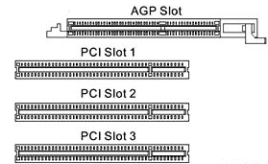

Depending on the width, function & technology, expansion slots can be divided into following categories.

* **AGP (Accelerated Graphic Port) Card**
* **AMR (Audio Modem Raiser) card**
* **ISA (Industry Standard Architecture)**
* **MCA (Micro Channel Architecture)**
* **EISA (Extended Industry Standard Architecture)**
* **PCI (Peripheral Component Interconnect/Interface)**

**AGP Slot & AGP Card**

AGP or AcceleratedGraphicPort is a high speed bus for the display graphics.

It is used for higher video performance or for running higher Game and application like AutoCAD, 3D Max, and Maya etc.

It is also interface between computers to TV (Tele Vision).

Some of the features of AGP bus are

* It allows the video board to use system memory (RAM), as video memory.
* It is four to eight times faster than the PCI.
* AGP slot on the motherboard can be easily distinguished because it is slightly offset from the other PCI slots is usually darker in color. As this slot is used only for display card motherboard have only one AGP slot.

When the AGP first came in the market its speed was 1x now latest P4 system offer 8x AGP slots.

It is available in market as its video memory capacity i.e.

64 MB graphic card, 128 MB …. , 256 MB..... , 512 MB….. , 1GB…, etc.

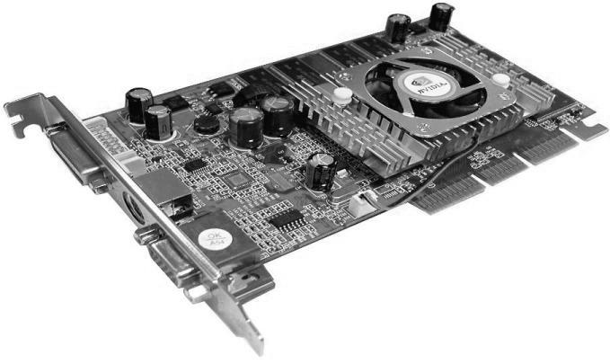

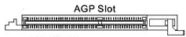

**PCI Slot & PCI Cards**

PCI stands for **“Peripheral Component Interface”**.

It is used for connect other device to your PC like Modem, Audio, VGA, Keyboard, Mouse, etc.

It is mostly in white color



***Different types of PCI cards, whichare installed in PCI slots.***

|  |  |
| --- | --- |
| ***[VGA] Display Card*** | ***LAN Card or***  ***NIC (Network Interface Card)*** |
|  |  |
| VGA Card | LAN |

|  |  |
| --- | --- |
| ***Sound Card*** | ***Modem Card*** |
|  |  |
| Sound Card | Internal Modem |
|  |  |
| ***USB connector Card*** |  |
|  |  |
| USB Card |  |

**Power Supply Connector**

It is two types of power supply connector.

AT (old type of power connector)

It is 6 + 6 = 12 pins connectors

ATX (new type of power connector)

It is 20/20 + 4=24 pins connector.

Normally AT 12 pins & ATX 20 pins connector.

|  |  |  |  |
| --- | --- | --- | --- |
| **AT Power Supply**  **(Old type of Power Connector)** | | | |
| ***Pin No.*** | ***Jack-1*** | ***Pin No.*** | ***Jack-2*** |
| **1** | **Power Good** | **7** | **Ground** |
| **2** | **+5V** | **8** | **Ground** |
| **3** | **+12V** | **9** | **-5V** |
| **4** | **-12V** | **10** | **+5V** |
| **5** | **Ground** | **11** | **+5V** |
| **6** | **Ground** | **12** | **+5V** |

|  |  |  |  |
| --- | --- | --- | --- |
| **ATX Power Supply**  **(New type of Power Connector)** | | | |
| ***Pin No.*** | ***Function*** | ***Pin No.*** | ***Function*** |
| **1** | **+3.3V** | **11** | **+3.3V** |
| **2** | **+3.3V** | **12** | **-12V** |
| **3** | **Ground** | **13** | **Ground** |
| **4** | **+5V** | **14** | **PWR ON** |
| **5** | **Ground** | **15** | **Ground** |
| **6** | **+5V** | **16** | **Ground** |
| **7** | **Ground** | **17** | **Ground** |
| **8** | **PWR Good** | **18** | **-5V** |
| **9** | **+5V SB** | **19** | **+5V** |
| **10** | **+12V** | **20** | **+5V** |



**CPU Fan Connector**

CPU fan connector provides +12V DC supply to the CPU cooling fan this fan is attached on top of the heat sink element.

|  |  |
| --- | --- |
| **Pin No.** | **Function** |
| **1** | **No connection** |
| **2** | **+12V** |
| **3** | **Ground** |

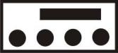

**ATX 12 V Connector**

It is 12V CPU power supply connector.

It is supplied the current to the microprocessor.

It is 4 pins connector.



**SMPS / Power Supply**

SMPS is stands for **“Switch Mode Power Supply”**.

Power supply is the heart of computer system. Like the human pumping blood to different parts of the body, the power supply provides various parts of the computer with clean DC (Direct Current) power supply to keep the computer alive and functioning.

The power supply converts high voltage AC (Alternate Current) power from the AC mains supply to DC power required by the computer.

The power supplies are rated in watts, currently power supplies of 260 or higher wattage is common.

A fan assembly is provided in the power supply to keep the computer cool, if this fan fails, the computer may overheat and start giving intermittent problems or may completely stop working.

SMPS are of two types,

AT SMPS (Advanced Technology) 6+6= 12 Pins power supply.

ATX SMPS (Advanced Technology Extended) 20+4=24 Pins power supply.

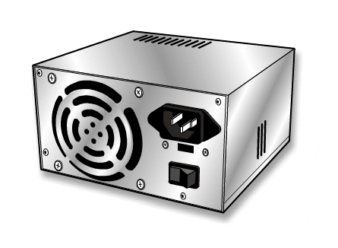

**Modem**

The Modem name is defined as **“MOD + DEM”**.

Where MOD means “Modular”& DEM means “Demodular”.

The modem is a device which allows you to connect your computer to any other computer by using a telephone line.

This allows you to communicate with the connected person, transfer data, copy and software/programs from the connected computer, sent and receive mail using e-mail etc.

Modem is available as two categories,

* **Internal Modem**
* **External Modem**

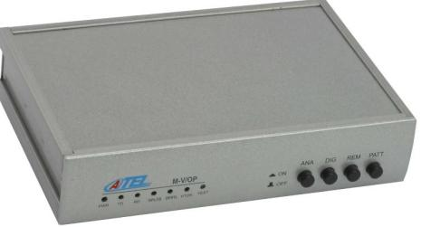

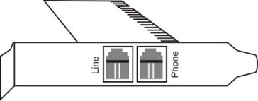

**Internal Modem External Modem**

***How modem works.***

Modem is a device that allows us to connect two computers using normal telephone line. The sending computers modem modulates the digital signal from computer, into analog signal required for transmission over the telephone line.

At the receiving end the incoming analog signal is given to the modem. This modem demodulates the analog signal back into digital signal and gives this signal to the computer.

**How to Install Floppy Drive**

***Requirements***

* **Floppy Disk Drive (FDD)**
* **34 Pins Data Cable**
* **4 Pins Power Cable (from SMPS)**
* **FDC on Motherboard (Floppy Drive Connector)**

***Procedure***

1. Shutdown the computer.
2. Open the cabinet.
3. Insert the Floppy Drive inside the floppy bays& fixed the screw.
4. Connect 34 pins data cable to the drive & FDC on the motherboard.
5. Connect the 4 pins power cable from power supply to the floppy drive.
6. Start the computer or boot the computer.
7. Press **“Delete/F2”** key from keyboard entering into BIOSsetup.
8. Enter on **“Standard CMOS Setup”**.
9. Configure setting as per your drive. Example 3.5”- 1.44 MB floppy drive (default)
10. Save Setting & Exit the setup by pressing **“F10”** function key on the keyboard then press “Y” and “Enter”.

**How to Install Hard Disk Drive**

***Requirements***

**(PATA/IDE HARD DISK DRIVE)**

* **IDE Hard Disk Drive**
* **40 Pins IDE Cable**
* **4 Pins Power Cable from SMPS**
* **IDEPort on Motherboard**

**(SATAHARD DISK DRIVE)**

* **SATA Hard Disk Drive**
* **SATA Data Cable**
* **SATA Power cable From SMPS/individual**
* **SATA Port on Motherboard**

***PROCEDURE***

* + 1. Shutdown the computer.
    2. Open the cabinet.
    3. Insert the PATA/SATA Hard Disk Drive inside the hard drive bays & fixed the screw from screw driver.
    4. Connect IDE/SATA data cable to the drive & onto the motherboard.

***Note: -***

While installing the IDE data cable configureyour Master & Slave setting fromthe jumper connector to the hard disk drive.

SATA hard disk not necessary any jumper Setting.

* + 1. Connect the 4pins/SATA power cable from power supply to the Hard disk drive.
    2. Start/Boot the computer.
    3. Press “Delete/F2” key on keyboard to enter into BIOS setup.
    4. Enter on “Standard CMOS Setup”.
    5. Detect the Hard Disk Drive.
    6. Enter into “Boot Sequences Option”.

**1st Boot Device------------CD-ROM**

**2nd Boot Device-----------Hard Disk**

**3rd Boot Device------------Floppy disk/Disable**

**Boot other Device---------Enable**

* + 1. Save Setting & Exit the setup pressing “F10” function key from the keyboard then press “Y” and “Enter”.
    2. Insert clean OS Bootable CD. (Windows 98, Windows 2000, Windows XP, Windows Vista, Win 2003 Server etc.)
    3. Create partition as per your choice.
    4. Format primary partition
    5. Install the Operating System as your active drive. (Windows 98, Windows 2000, Windows XP, Windows Vista, Win 2003 Server, Linux etc.)

**How to Install CD/DVD ROM Drive**

***REQUIREMENTS***

* **CD/DVD-ROM Drive**
* **40 Pins IDE Cable**
* **4 Pins Power Cable from SMPS**
* **IDE Port on Motherboard**

**(SATA DVD-ROM DRIVE)**

* **SATA DVD ROM Drive**
* **SATA Data Cable**
* **SATA Power cable From SMPS/individual**
* **SATA Port on Motherboard**

***PROCEDURE***

1. Shutdown the computer.
2. Open the cabinet.
3. Insert the CD/DVD-ROM drive into its bays & fixed the screw from screw driver.
4. Connect 40 pins IDE data cable to the drive & on to the motherboard.
5. Connects the 4 pins power supply to the drive.
6. Start/boot the computer.
7. Press “Delete” key from the keyboard to entering into BIOS setup.
8. Enter on “Standard CMOS Setup”.
9. Detect CD-ROM drive.
10. After detecting CD-ROM drive Save Setting & Exit the setup pressing “F10” function key from the keyboard then press “Y” and “Enter”.

**Virus**

Virus is stands for **“Vital Information Resources Using Seize”**.

Many of the Virus infection produce a system, as if there is some software/hardware problem with the computer.

A computer Virus is nothing but a small program written by someone to corrupt or damage the information stored in the computer system and to replicate itself from one computer system to another computer.

The term virus is used for this type of programs because as the biological virus spread disease from one person to another these Virus programs also spread from one computer to another.

These viruses spread when someone copies a Virus infected programfrom one computer and runs it on some other computer. This infects the new computer system. Again, when someone copies from this newly infected system, the virus will again spread and the spreading of the virus continues.

A virus cannot spread by using any data file such as text file, image file, sound file etc. A virus needs some kind of executable program such as, .EXE, .COM, .SYS, Window Macro etc. to become active, infect a system and spread.

***Types of Computer Viruses***

* Worm
* Trojan
* Bomb
* MBR (Partition Table) Infector
* DBR (Boot Sector) Infector
* Program/File Infector (Parasitic Virus)

***How Does a VIRUS Work?***

A virus comes to a system from another infected system, may be by copying a program from the infected system, or booting an infected floppy, CD or from opening any infected file over the network.

Once a virus infects a system it becomes memory resident, every time the infected part of the system is used.

For example, a virus that has infected MBR, DBR or the system files, will become active every time the system is switched on or a virus that has infected a .COM or .EXE program will become active when that particular infected program is run.

***Where Do Viruses Live?***

A virus is a computer program, it cannot do anything unless it is executed, for this reason the virus program writers makes these virus programs to infect some executable program, or some executable part of the drive such as MBR, DBR etc.

A virus can never spread if you copy the data file from one infected floppy or hard disk drive and use it on some other clean system

**Keeping Virus Away**

Follow Method to keep the virus away from infection your system.

To prevent a virus infection one method could be to never to use the floppy disk, network, modem etc., but this is not possible in the real life, without an exchange of data and program a computer will not be of much use.

Therefore, to prevent a virus infection one can take some precaution such as

**Keep the floppy disk drive door open**

Whenever the system is booted from a hard disk drive, if you have some disk in the floppy drive then keeps the drives door open.

Keeping the door closed will give the boot sector virus from the floppy disk to become active.

**Do not use pirated software**

Pirated software, specially games and demonstration packages are one of the main carriers of the viruses.

Buy original software from the known dealers, this keep your system virus free.

**Get share ware for some reputed company**

Shareware software should be obtained from some reputed dealer or directly from the program author. This again will reduce the chance of virus infecting your system.

**Run virus scanner/checker program regularly**

One should run the latest available virus scanner program regularly. DOS provides MSAV (Microsoft Anti Virus) program with the current version of DOS. This can be used to regularly check the system for any infection.

Also some other good virus scanning programs such as Nashot from Nash System, SCAN from MacAfee Associates, Norton Anti Virus from Norton etc. are available.

**Always keep current version of Anti-virus software**

Everyday some new virus is made so; you cannot get a virus scanner, install it and forget about it. The old virus scanner may not recognize new viruses so always try to get the latest version of the scanner software. Keep the software up-to-date by getting current version.

**Backup the data regularly**

Finally, even after all this precaution you may get infected. Therefore, whatever protection you follow, you must back up your important data regularly. This will help in the worst virus infection. You can always reformat and restore the data.

**Take care when downloading files from internet**

When downloading files from the Internet is should be scanned properly. Download files from reputable web sites such as shareware.com, tucows.com etc.

***Virus Infection Systems***

**Unexplained slowdown of the system**

This is one main system of the virus infection. If the system without any apparent reason starts to take more time to load programs from the disk or starts to operate slower than its normal speed then you can suspect a virus infection.

**Decrease in the amount of available memory**

This is another symptom of virus infection. When checked with the CHKDSK, the system shows some KB memory missing from the main memory or when checked with the MEM/D/P commend, the memory module list shows some program resident in the memory without any proper module name.

**Increase in bad sectors/lost clusters etc.**

When the number of bad sectors start increasing, or when the number of lost clusters reported by the SCANDISK or CHKDSK start increasing without any special reason them one main reason behind this could be virus infection.

**Cannot execute executable files**

If you find that the executable files (.EXE, .COM) which you were able to execute till yesterday start missing from the directories or when executing them you start getting some error messages then this again could be one major indication of the virus attack.

***Anti-Virus***

It is application software which is used to scan virus in your system. Anti-virus is used to remove virus, infected files and protect computer from viruses. Some Anti-virus software are repaired infected files.

Types of Anti-viruses

* AVG
* MacAfee
* Symantec Norton
* Quick Heal
* Panda
* Kasper Sky
* Avira

Some Common Virus Myths

* Virus can destroy all data on the disk
* If a file is damaged it must be some virus infection
* Virus can hide in data file
* Data backup after virus infection is useless
* Read/only files are safe from virus
* Write protected floppies can be infected by virus
* Anti-virus software or hardware can protect from all viruses

**MS-DOS**

***Introduction***

DOS is an operating system used on PCs (Personal Computers).

The Operating System is software which controls the hardware of the machine (the disks, keyboard, mouse, monitor, etc.) and allows the user's programs and packages to be run on the machine. It is the interface between your word processor or spreadsheet or other program and the electrical signals which the CPU (the Central Processing Unit or Processor), the heart of the computer, understands.

It is working on command option. Without command we can’t run the Dos function, it is produced by Microsoft Company.

***How to Start Ms Dos in Windows –***

* Start…….Program……..Accessories……..Command Prompt.
* Start……..Run……..Type (COMMAND or CMD)……..OK.

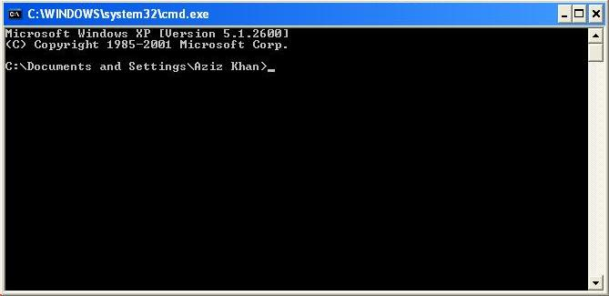

***Commands***

***VER***

***(Version)***

This command is used to see the current operating system& Version of that operating system.

***TIME***

This command is used to see the current time & to change the time.

***DATE***

This command is used to see the current date & to change the date.

***C:***

***(Drive letter with Colon)***

This command is used to change your current drive.

***MD (Folder name)***

(Make directory / Make Folder)

This command is used to create a folder in your current location.

***RD (Folder Name)***

(Remove Directory/ Remove Folder)

This command is used to remove/delete any folder.

***CD (Folder Name)***

(Check Directory)

This command is used to remove/delete any folder.

***CD..***

This command is used to come back one directory/folder.

***CD\***

This command is used to come back on your current drive / root directory.

***DIR***

This command is used to see the files and folder in your current folder/drive.

***DIR A???.\****

***DIR/P*** (Pause between page)

***DIR/W*** (Wide screen format)

***DIR/S*** (Display system files & folder)

***DIR/AH*** (Display all hidden file/folder)

***DIR/AS*** (Display all system hidden files)

***CLS***

This command is used to clear the Dos screen.

***Ctrl+C***

This command is used to come out the current action.

***Alt + Enter***

This command is used to do full screen of DOS window.

***COPY CON * . \****

This command is used to create new file.

(Where left side * is known as file name & right side * is file extension.)

***Ctrl + Z***

This command is used to save the file.

***DEL *.\****

This command is used to delete all files or a particular file from your folder or drive.

***EDIT *.\****

This command is used to create a new file or modifies an existing file.

***TYPE *.\****

This command is used to display the text file like word, excel, notepad file, etc.

***COPY (Source Location) (Destination Location)***

This command is used to copy files or folders one place to another place.

***XCOPY (Source Location) (Destination Location)***

This command is used to copy files or folders one place to another place.

***MOVE (Source Location) (Destination Location)***

This command is used to cut/move files or folders one place to another place.

***REN (Folder Old Name) (Folder New Name)***

This command is used to rename your folders or files.

***EXIT***

This command is used to close the DOS window.

***ATTRIB***

This command is used to set the file property.

**A -** Archive file attribute

**R -** Read only file attribute (file cannot be deleted or edited but can be listed with DIR and viewed and copied)

**S -** System file attribute (file cannot be deleted or copied, nor is it visible with the DIR command but it can be edited)

**H -** Hidden file attribute (same properties as S)

***CHKDSK C:***

(Check Disk)

This command is used to scan/check your drive for bad sector.

***FDISK***

This command is used to create primary and logical partition to the drive.

***FORMAT D:***

This command is used to format created partition.

**Some Common Points**

***Administrator***

For Windows XP Professional, a person responsible for setting up and managing domain controllers or local computers and their user and group accounts, assigning passwords and permissions, and helping users with networking problems. Administrators are members of the Administrators group and have full control over the domain or computer.

***Boot files***

The system files needed to start Windows. The boot files include **NTLDR** and **Ntdetect.com**.

***Codec***

Hardware that can convert audio or video signals between analog and digital forms (coder/decoder); hardware or software that can compress and uncompress audio or video data (compression/decompression); or the combination of coder/decoder and compression/decompression. Generally, a codec compresses uncompressed digital data so that the data uses less memory.

***Defragmentation***

The process of rewriting parts of a file to contiguous sectors on a hard disk to increase the speed of access and retrieval. When files are updated, the computer tends to save these updates on the largest continuous space on the hard disk, which is often on a different sector than the other parts of the file. When files are thus fragmented, the computer must search the hard disk each time the file is opened to find all of the file's parts, which slows down response time.

***DirectX***

An extension of the Microsoft Windows operating system. DirectX technology helps games and other programs use the advanced multimedia capabilities of your hardware.

***Drive***

An area of storage that is formatted with a file system and has a drive letter. The storage can be a floppy disk, a CD, a hard disk, or another type of disk. You can view the contents of a drive by clicking its icon in Windows Explorer or My Computer.

***Drive letter***

The naming convention for disk drives on IBM and compatible computers. Drives are named by letter, beginning with A, followed by a colon.

***Extended partition***

A type of partition that you can creates only on basic master boot record (MBR) disks. Extended partitions are useful if you want to create more than four volumes on a basic MBR disk. Unlike primary partitions, you do not format an extended partition with a file system and then assign a drive letter to it. Instead, you create one or more logical drives within the extended partition. After you create a logical drive, you format it and assign it a drive letter. An MBR disk can have up to four primary partitions, or three primary partitions, one extended partition, and multiple logical drives.

***File system***

In an operating system, the overall structure in which files are named, stored, and organized. NTFS, FAT, and FAT32 are types of file systems.

***File Allocation Table (FAT)***

A file system is used by MS-DOS and other Windows-based operating systems to organize and manage files. The file allocation table (FAT) is a data structure that Windows creates when you format a volume by using the FAT or FAT32 file systems. Windows stores information about each file in the FAT so that it can retrieve the file later.

***FAT32***

A derivative of the file allocation table (FAT) file system. FAT32 supports smaller cluster sizes and larger volumes than FAT, which results in more efficient space allocation on FAT32 volumes.

***NTFS file system***

An advanced file system that provides performance, security, reliability, and advanced features that are not found in any version of FAT. For example, NTFS guarantees volume consistency by using standard transaction logging and recovery techniques. If a system fails, NTFS uses its log file and checkpoint information to restore the consistency of the file system. In Windows 2000 and Windows XP, NTFS also provides advanced features such as file and folder permissions, encryption, disk quotas, and compression.

***Hub***

A common connection point for devices ina network. Typically used to connect segments of a local area network (LAN), a hub contains multiple ports. When data arrives at one port, it is copied to the other ports so that all segments of the LAN can see the data.

***Virtual Memory***

Temporary storage used by a computer to run programs that need more memory than it has. For example, programs could have access to 4 gigabytes of virtual memory on a computer's hard drive, even if the computer has only 32 megabytes of RAM. The program data that does not currently fit in the computer's memory is saved into paging files.

Virtual memory is a system where all physical memory is controlled by the operating system. When a program needs memory, it requests it from the operating system. The operating system then decides what physical location to place the memory in.

This offers several advantages. Computer programmers no longer need to worry about where the memory is physically stored or whether the user's computer will have enough memory. It also allows multiple types of memory to be used. For example, some memory can be stored in physical RAM chips while other memory is stored on a hard drive. This drastically increases the amount of memory available to programs. The operating system will place actively used memory in physical RAM, which is much faster than hard disks. When the amount of RAM is not sufficient to run all the current programs, it can result in a situation where the computer spends more time moving memory from RAM to disk and back than it does accomplishing tasks; this is known as thrashing.

Virtual memory systems usually include protected memory, but this is not always the case.

***Paging File***

A hidden file on the hard disk that Windows uses to hold parts of programs and data files that do not fit in memory. The paging file and physical memory, or RAM, comprise virtual memory. Windows moves data from the paging file to memory as needed and moves data from memory to the paging file to make room for new data. Paging file is also called a swap file.

***Cache memory***

Cache memory is random access memory (RAM) that a computer microprocessor can access more quickly than it can access regular RAM. As the microprocessor processes data, it looks first in the cache memory and if it finds the data there (from a previous reading of data), it does not have to do the more time-consuming reading of data from larger memory.

Cache memory is sometimes described in levels of closeness and accessibility to the microprocessor. An L1 cache is on the same chip as the microprocessor. (For example, the PowerPC 601 processor has a 32 kilobyte level-1 cache built into its chip.) L2 is usually a separate static RAM (SRAM) chip. The main RAM is usually a dynamic RAM (DRAM) chip.

In addition to cache memory, one can think of RAM itself as a cache of memory for hard disk storage since all of RAM's contents come from the hard disk initially when you turn your computer on and load the operating system (you are loading it into RAM) and later as you start new applications and access new data. RAM can also contain a special area called a disk cache that contains the data most recently read in from the hard disk.

***L1 and L2***

L1 and L2 are levels of cache memory in a computer. If the computer processor can find the data it needs for its next operation in cache memory, it will save time compared to having to get it from random access memory. L1 is "level-1" cache memory, usually built onto the microprocessor chip itself. For example, the Intel MMX microprocessor comes with 32 thousand bytes of L1.

L2 (that is, level-2) cache memory is on a separate chip (possibly on an expansion card) that can be accessed more quickly than the larger "main" memory. A popular L2 cache memory size is 1,024 kilobytes (one megabyte).

***Flash memory***

Flash memory is a type of constantly-powered nonvolatile memory that can be erased and reprogrammed in units of memory called blocks. It is a variation of electrically erasable programmable read-only memory (EEPROM) which, unlike flash memory, is erased and rewritten at the byte level, which is slower than flash memory updating.

Flash memory is often used to hold control code such as the basic input/output system (BIOS) in a personal computer. When BIOS needs to be changed (rewritten), the flash memory can be written to in block (rather than byte) sizes, making it easy to update. On the other hand, flash memory is not useful as random access memory (RAM) because RAM needs to be addressable at the byte (not the block) level.

Flash memory gets its name because the microchip is organized so that a section of memory cells are erased in a single action or "flash." The erasure is caused by Fowler-Nordheim tunneling in which electrons pierce through a thin dielectric material to remove an electronic charge from a floating gate associated with each memory cell. Intel offers a form of flash memory that holds two bits (rather than one) in each memory cell, thus doubling the capacity of memory without a corresponding increase in price.

Flash memory is used in digital cellular phones, digital cameras, LAN switches, PC Cards for notebook computers, digital set-up boxes, embedded controllers, and other devices.

**Software Installation**

**Windows XP installation step by step screenshots**

**How to install Windows XP step by step**

**System Requirements for Windows XP Service Pack 2**

The system requirements for Windows XP Service Pack 2 (SP2) are not that different from the original requirements of Windows XP. For this reason, anyone who is already operating XP should easily be able to upgrade to SP2. Check your computer to make sure that you meet a few minimum requirements to support the upgrade to Windows XP SP2.

## CPU

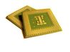Microsoft suggests using a "Pentium 233-megahertz (MHz) processor or faster (300 MHz is recommended)." Although some people have installed Windows XP on systems with slower processor speeds, this is not an ideal setup. Also, the XP operating system requires a Pentium class processor due to the use of instructions, which are only compatible with these newer processors.

## Memory or RAM

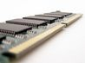According to Microsoft, “you should have at least 64 (MB) of RAM (128 MB is recommended)”. Keep in mind, however, that more memory will equal better performance and 128 MB is the minimum recommended amount of memory for Windows XP SP 2.

## Hard Drive

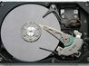The recommendation from Microsoft stipulates "at least 1.5 gigabytes (GB) of available space on the hard disk." This is only for the original installation of Windows XP and is the only system requirement, which is increased by the installation of Service Pack 2. The new recommendation is an additional "1560 MB peak usage during installation" and brings the total requirement suggested by Microsoft to 3.0 GB.

## Optional Items

These remaining items are listed as requirements by Microsoft; however, there are many cases of installations without these components. With very few exceptions, most computers have the requisite CD-ROM or DVD-ROM drive, keyboard and a Microsoft Mouse or some other compatible pointing device, Video adapter and monitor with Super VGA (800 x 600) or higher resolution, Sound card, Speakers or headphones. Keep in mind that without the sound card or speakers, the computer will still work, only without sound. Additionally, there are methods for installing Windows XP Service Pack 2 which may, or may not, require the use of any of these optional items. Such methods are typically reserved for advanced users and network administrators.

***Here*** is a basic guide to install Windows XP (for beginner Student). Before proceeding with the installation, please make sure you have a compatible hardware resource, Windows XP installation CD/DVD and Windows XP Key.

***Let’s start...*** Put the Windows XP installation CD / DVD into the CD / DVD Drive.   
» Press **F12** or **Delete Key** (Depends upon your Motherboard/Brand). Select CD-ROM Drive

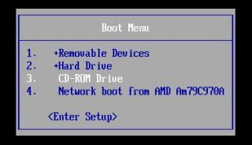[Or]

» You can change first boot device to CD-ROM in Bios Setup (Mostly F2 key for Bios setup).

#### Installation will start now. (Follow the Screenshots and steps).

### WindowsXP-step-1

**Step 1 »** The Setup starts now (you will see the screen like the picture 1).

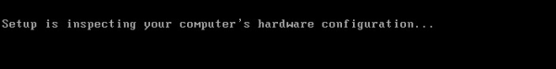

**Step 2 »** Inspecting something (secret.., Do not press anything until you see the next step screen).

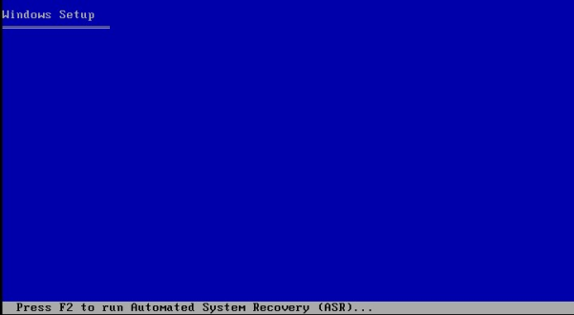

**Step 3 »** Press **Enter** for new installation.

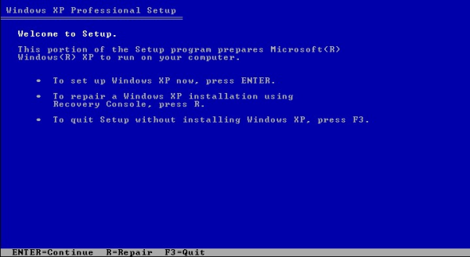

**Step 4 »** Press **F8** to agree terms and conditions (For information read it care fully).

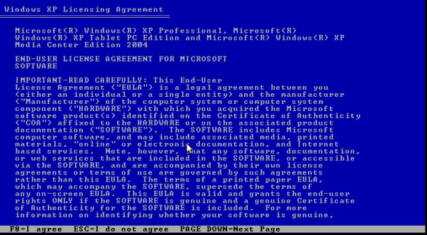

**Step 5 »** It will show the Unpartitioned space of your Hard disk (picture shows the space in MB i.e., 40GB). Press **C** to create a partition (Press Enter if you want to use whole hard drive as a single partition).

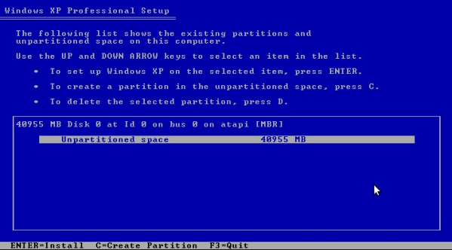

**Step 6 »** Now you need to decide how much space you need for OS drive (i.e., C drive). For Windows XP 25 GB is enough, just type 25600 (25 GB = 25600 MB) and press **Enter**

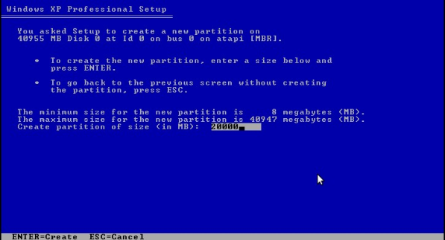

**Step 7 »** Now it will show the allocated space for OS drive and remaining space left on the hard disk . Just press **Enter** (we can create more Drives later).

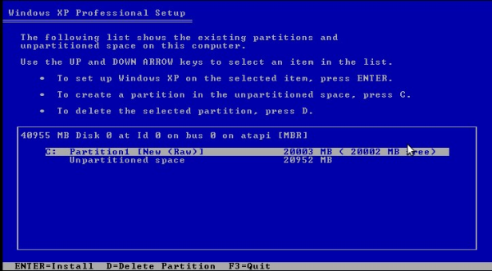

**Step 8 »** Now chooses the type of Format. Just choose NTFS (Quick) first option and press **Enter** (Beginners, no questions).

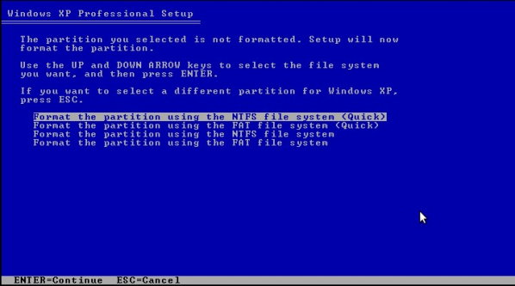

**Step 9 »** Setup is formatting the OS drive. (No need to do anything until step 13).

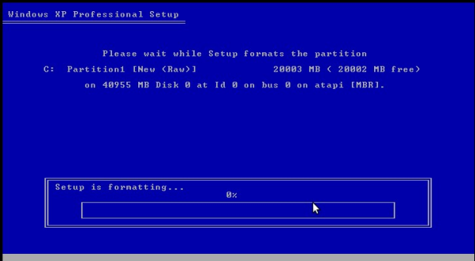

**Step 10 »** Setup will copy some files for installation.

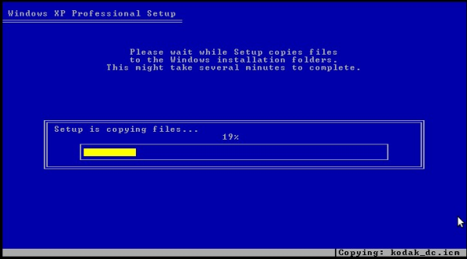

**Step 11 »** System will get restarted after coping files.

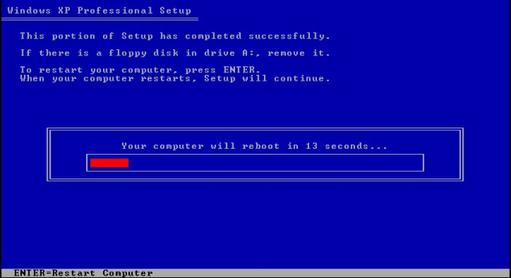

**Step 12** » Setup will install something in the background (hey wait, not exactly in the back. just relax).

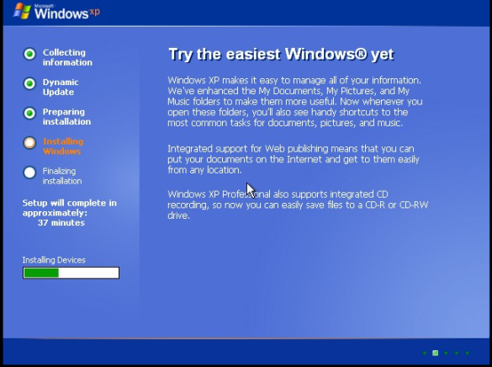

**Step 13 »** Just leave as it is and press **Next**.

* Here it may ask windows XP product key. Just type a valid key and press N**ext** (After validating your key it will go to next step).

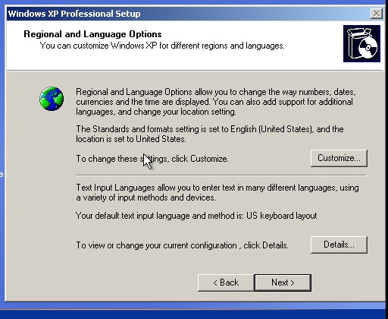

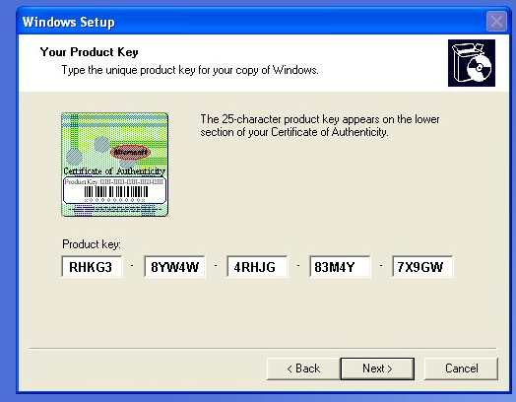

**Step 14 »** Type your name and organization name. Press **Next**.

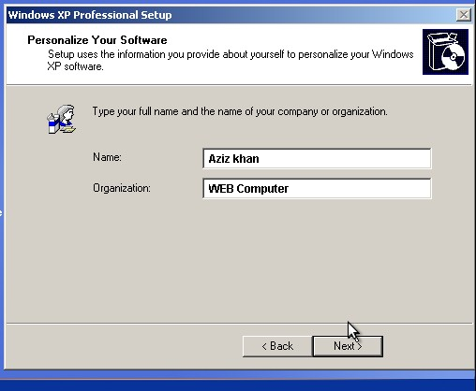

**Step 15 »** Type name of your computer and type administrator password or leave as it is and press **Next** (We can change later).

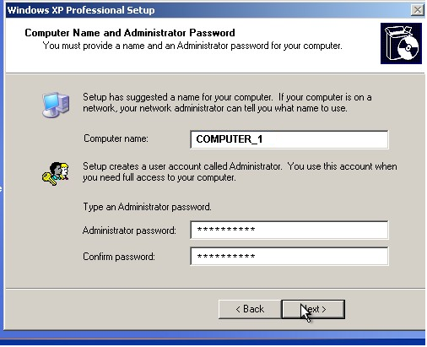

**Step 16 »** Select your Time zone and press **Next**.

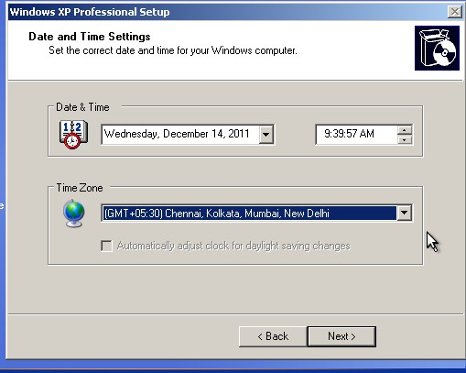

**Step 17 »** Again it will install something in the background.

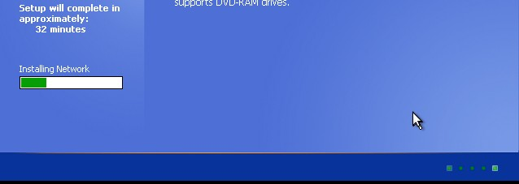

**Step 18** » Now you need to setup network connection. Choose typical and press **Next** (no one wants to assign IP, if you need you can choose custom and do it on your own).

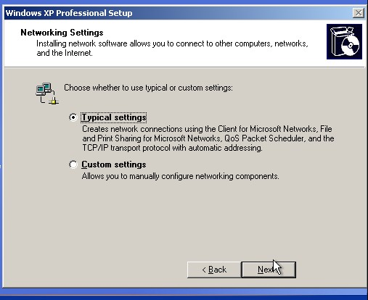

**Step 19 »** Leave as it is, Please press **Enter**.

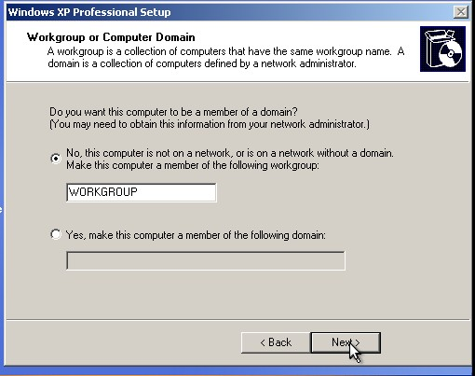

**Step 20 »** It will install, registers and save etc….. (No need to do anything)

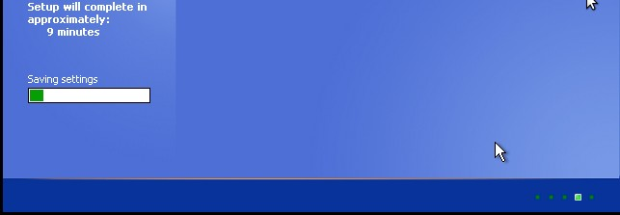

**Step 21 »** System will get restarted. You will see the screen like Picture 21.

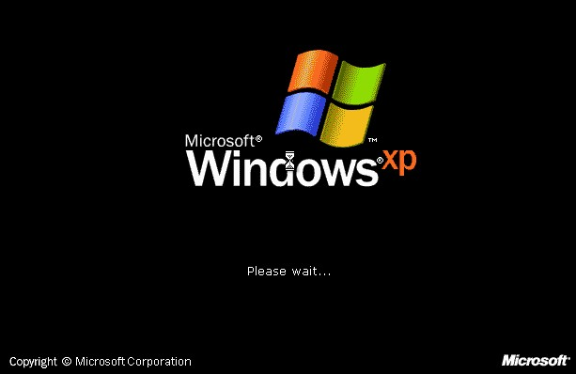

**Step 22 »** Just Press **OK**. It will automatically adjust your screen resolutions.

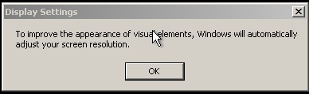

**Step 23 »** Just press **OK** to adjust monitor settings automatically.

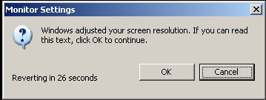

**Step 24 »** Now you will see a welcome note from windows. Press **Next**.

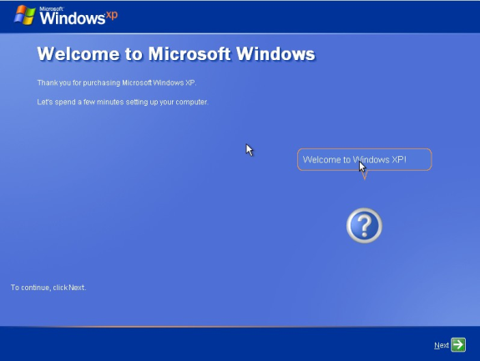

**Step 25 »** Choose first option to update your Windows automatically. Press **Next**.

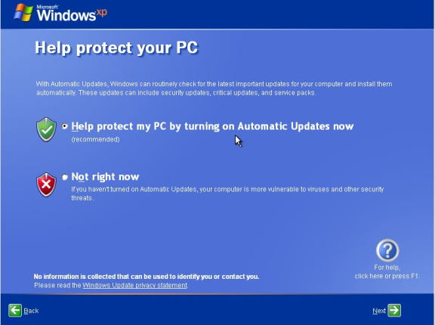

**Step 26 »** In this step it will check for the internet connectivity. Press **skips** (if you don’t want to wait) or press **next** after checking.

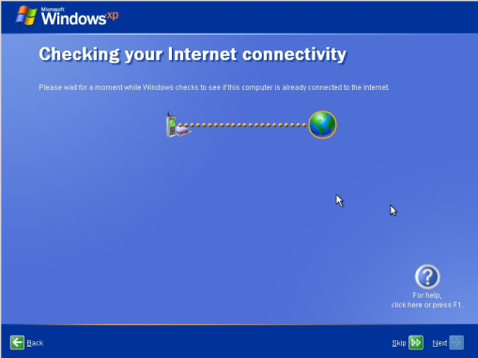

**Step 27 »** choose whatever you want (we can change it later). Press **skip** or **next** (which one is visible).

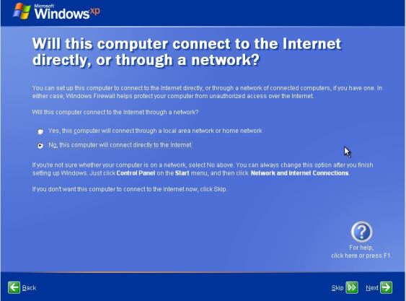

**Step 28 »** Choose second option and press **Next**.

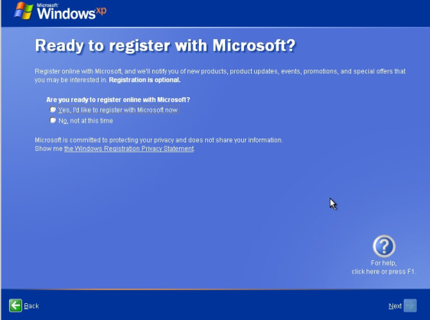

**Step 29 »** just types the user name for login and press **Next**.

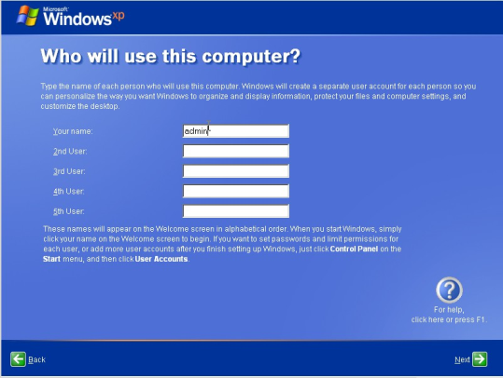

**Step 30 »** At last, you made it. Press **Finish**.

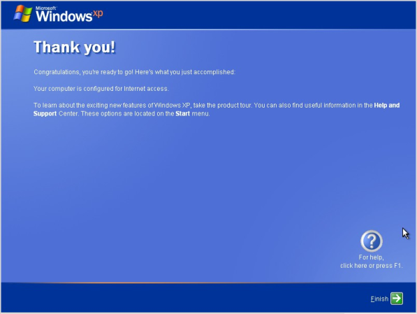

**Step 31** ».

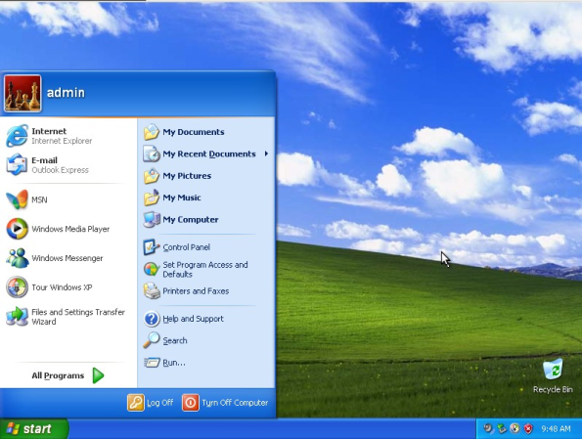

**How to Install Windows 7 (Step-By-Step Tutorial with Screenshots)**

## Planning the Installation

As with any OS installation, we must first plan the installation process. When you run the Windows 7 Setup program, you must provide information about how to install and configure the operating system. Thorough planning can make your installation of Windows 7 more efficient by helping you to avoid potential problems during installation. An understanding of the configuration options will also help to ensure that you have properly configured your system.

Here are some of the most important things you should take into consideration when planning for your Windows 7 installation:

* Check System Requirements
* Check Hardware and Software Compatibility
* Determine Disk Partitioning Options
* Complete a Pre-Installation Checklist

Microsoft states the minimum recommended specs for Windows 7:

* **1 GHz 32-bit or 64-bit processor**
* **1 GB of system memory**
* **16 GB of available disk space**
* **Support for DirectX 9 graphics with 128 MB memory (to enable the Aero theme)**
* **DVD-R/W Drive**
* **Internet access (to activate and get updates)**

## 32-bit or 64-bit Version?

You need to decide whether to install the 32-bit or 64-bit version of Windows 7. The Windows 7 installation disc package includes both 32-bit and 64-bit versions of Windows 7. Basically, the 64-bit version of Windows handles large amounts of random access memory (RAM) more effectively than a 32-bit system. So if you plan on using Windows 7 on a computer with more than 3 GB or RAM, I would strongly suggest using the 64-bit version. Most programs designed for the 32-bit version of Windows will work on the 64-bit version of Windows, and if they don't, you can always use Windows XP Mode.

**Note**: Either way, you cannot use an existing 32-bit version of a previous OS to perform an in-place upgrade to a 64-bit version of Windows 7, and you'll need to format and install a fresh copy. Also, you cannot use an existing 64-bit version of a previous OS to perform an in-place upgrade to a 32-bit version of Windows 7.

## Type of Installation

Basically, there are 2 approaches to installing Windows 7:

1. **Upgrade** (In-place upgrade) - This option replaces your current version of Windows with Windows 7, and keeps your files, settings, and programs in place on your computer.
2. **Custom** ("fresh" installation) - This option replaces your current version of Windows with Windows 7, but doesn't preserve your files, settings, and programs. It's sometimes referred to as a clean installation for that reason.

As always, a fresh installation is much better and I strongly recommend taking that track. Even if you've got an existing Windows XP/Vista OS on your computer, I would strongly recommend that you format it and install a fresh copy of the OS.

## Beginning the Installation Process

When installing on a physical computer insert your Windows 7 DVD media into your DVD drive and reboot your computer. If you're asked to press a key to boot from DVD or CD, press any key. A black window will appear momentarily while the DVD content is read.

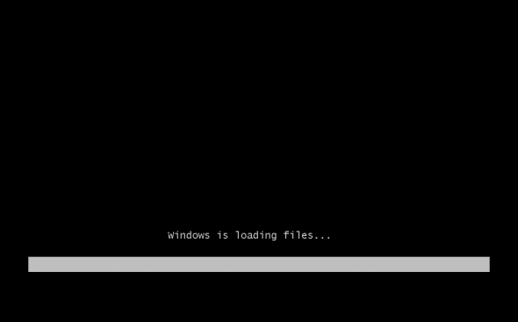

**Note**: These screenshots are taken from a Windows 7 Ultimate installation performed on a virtual machine running on VMware Workstation. I will be using an .ISO file mounted on the VMs CD/DVD drive.

Next, a **Starting Windows** screen will appear.

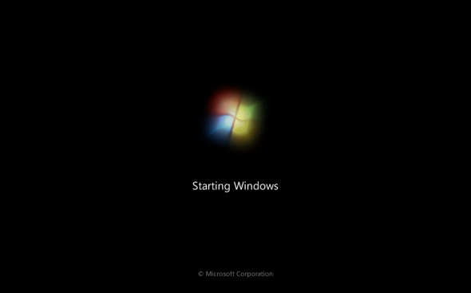

**Note**: If the Windows installation page doesn't appear and you're not asked to press a key to start from DVD or CD, you might have to specify that your computer uses its DVD or CD drive as the startup device.

## The Installation Process

Like in Windows Vista and Windows Server 2008, and unlike previous versions of Windows, Windows 7 does not have a noticeable text phase of the setup process, and it will boot directly into the Graphical User Interface (GUI) mode.

After a few moments you will see the first prompt:

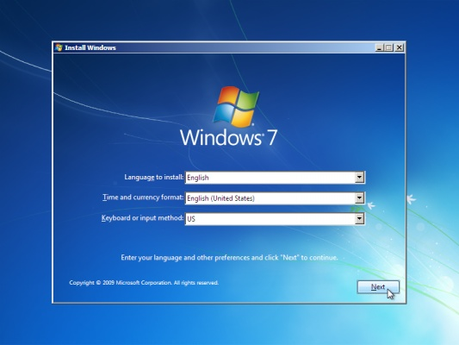

Click "Next" unless you want to change some regional settings for the installation process.

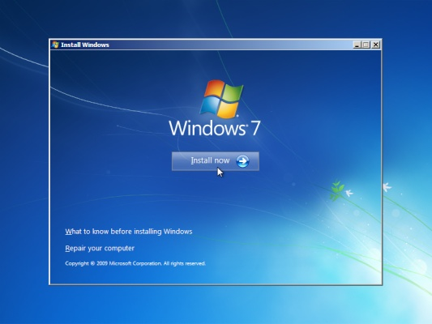

Click on the "Install now" button.

Next, accept the license terms and click on "Next".

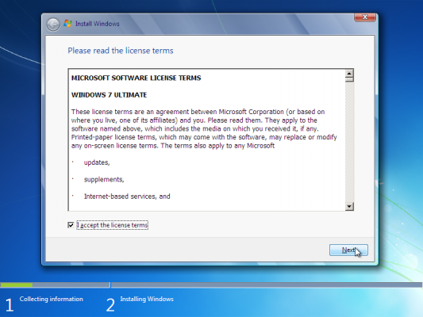

Next, unless you're upgrading an existing Windows installation, press the Custom (Advanced) installation type button. Note that in this case, the Upgrade button is disabled because this specific installation if performed on a new computer without any previous operating system on it.

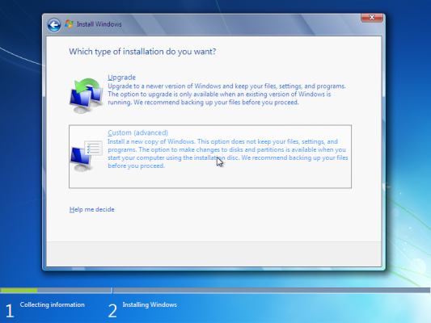

The next phase is to pick the installation partition. Since this computer has a new hard disk that hasn't been formatted before, you will only have the option to create a new partition on it.

If you don't want to specify a specific partition to install Windows on, or create partitions on your hard disk, click Next to begin the installation. If you already have another existing partition with enough free space and want to install the Windows 7 on that partition to create a multiboot configuration, select the partition you want to use, and then click Next to begin the installation. If you want to create, extend, delete, or format a partition, click Drive options (advanced), click the option you want, and then follow the instructions.

Since I don't need to perform any additional task I will just click on the "Next" button. The installation process will then create a partition on all the available disk space, and format it.

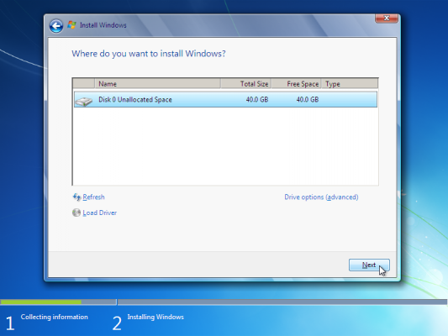

The setup process will now begin to copy files from the installation DVD media to the hard disk.

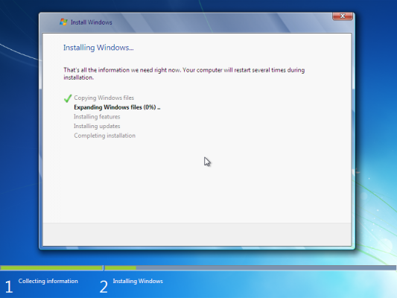

Process could take a while depending on the type of hardware your computer uses. In my VM test sample I've used for this demo, the entire process finished before I could finish writing the previous 3 paragraphs, so it could be pretty quick.

The computer will reboot, and the next thing you'll see is the prompt to set the user's and computer's name. By default, the computer's name will be username-PC, where username is the username you've entered.

**Note**: The user you're creating will be the only user currently available on the system. Like Vista, the built-in Administrator's account is disabled.

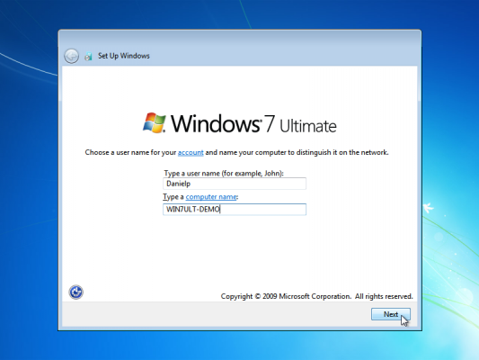

Enter the user's password. Remember this password, as it will be the ONLY user on the system, and unless you create an additional user or enable the built-in administrator account, if you forget this password you'll need to crack it to gain access to the system. The best option would be to choose a complex password made of at least 7 characters or more (something like Pssw0rd or MYpa$$w0rd). You must also enter a password hint.

Click on "Next".

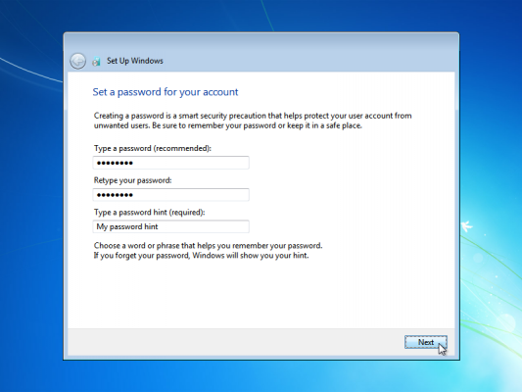

Next, type in your product key. If you do not have the product key at hand you can still click "Next", and proceed with the installation. You will be asked to enter the product key after Windows is installed.

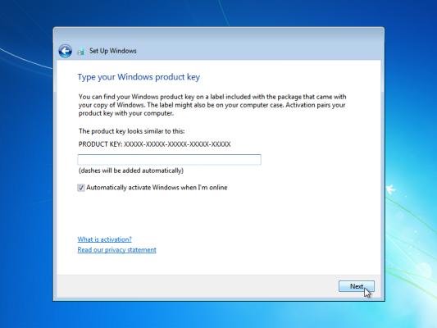

Choose what sort of protection your computer gets. The recommended settings are best for someone that doesn't plan to hide their computer behind a corporate firewall (and even then, in some cases, this would be the best option). If you plan to install a 3rd-party firewall later you can opt to be prompted later. Note that this setting will also have effect on how the computer uses the Microsoft Windows Update (Automatic Updates) features.

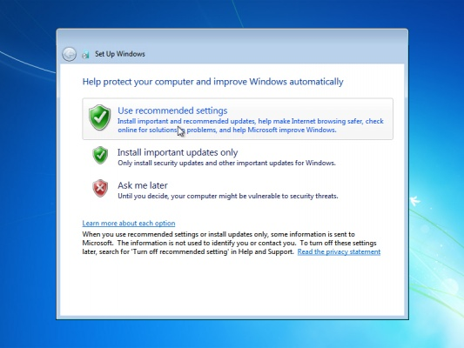

Choose your time zone and location and click on "Next".

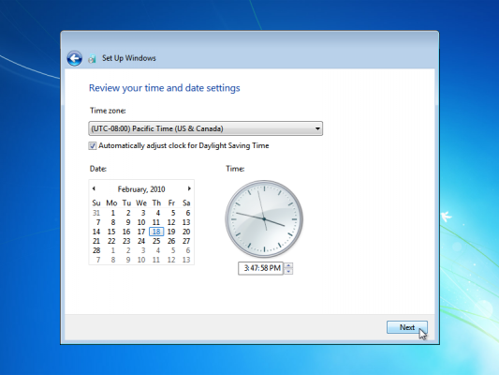

Select your network location type. This setting can be changed later, but do note that choosing a profile will have effect on the Windows Firewall and sharing settings. Click on "Next".

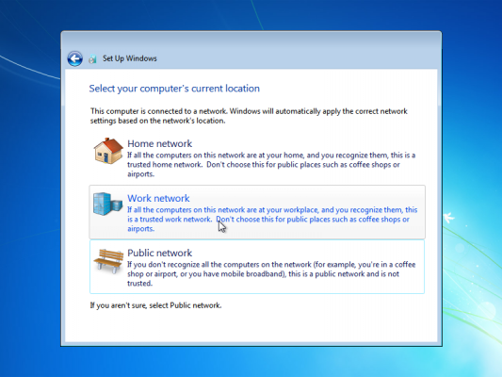

Windows will finalize the settings and your desktop will appear.

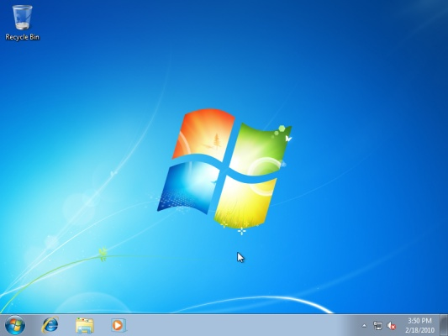

His concludes the Windows 7 installation. Next, you would probably want to update your computer with the latest hot fixes and/or patches from Microsoft.